­Zoom id : class_operations+ac19@geeksforgeeks.org

Password: Gfg@2025

sudhakarreddy2000

Geeks4Geeks

5th April

Sudhakar Reddy

MERN:

Stack: ex: stack of books

stack of technologies.

FullStack:

Front-End + Back-End

UI Designer

UI Developer

Responsive Web Designer

client side coding

Server side coding

html

css

bootstrap

javascript

react

Nodejs

Express

Mongodb

12th April:

Website: website is a collection of webpages. Each webpage provides information in the form of text, images, graphics, animation, hyperlinks etc.

Home page: It is a landing page / first page of a website from where we can connect to an other pages.

Home page name should be index.html

Browser: Browser is a software/application which is used for loading/visiting websites.

URL:Uniform Resource Locator

HTTP: Hyper Text Transfer Protocol

FTP:File Transfer Protocol

Requirement for a website:

1. Domain Name Registration

2. Hosting / server space

3. Designing / Developing

colors:16.7 million colors

RGB

R=>255

G=>255

B=>255

Fonts:

images:

19th April:

HTML5 and CSS3

Hyper Text Markup Language

To create any web application we need to use/write html code

html is simple, English like code.

html is not case sensitive.

html contains commands.

html commands are called TAGS

html tags are 2 types

1)Opening Tag

ex: <title>

2)Closing Tag

ex: </title>

HTML files has to be saved as .html

What you required to write html code and to execute it:

1)Text editor

ex:notepad, Visual Studio Code

2) Browser

ex:Chrome, safari, edge

<br> ==>break

<hr> ==>horizontal ruler

ATTRIBUTES:

Attributes are used inside opening tag, which are used to give style little bit for a particular tag.

<body bgcolor='yellow'>

</body>

Attributes for <hr> tag

color

size

align

width

ex:

<hr color="red" size="20px" width="500px" align="right">

Heading tags:

6 types of heading tags

<h1> </h1>

<h2> </h2>

<h3> </h3>

.

.

<h6> </h6>

Attributes for headings

align="left/center/right"

PARAGRAPH:

<p> </p>

Attributes for paragraph tag

align="left/center/right"

LIST ITEMS:

List items are 2 types:

1) order list item

<ol> </ol>

2) unorder list item

<ul> </ul>

Color for text using inline css:

---------------------------------------

<h1 style="color:red;"> color </h1>

Inserting images:

<img>

<img src="file.jpg/gif/png/svg" />

Attributes for img tag

width

height

border

alt

title

20th April:

Tables:

Tables are used to organize content.

table contains rows and columns.

<table> </table>

<tr> </tr> ==>table row

<td> </td> ==>table data

<th> </th> ==>table head

Hyperlinks:

=========

<a href="file.html"> clickme </a>

a=>anchor

href=>hyper reference

FORMS:

==========

<form> </form>

<input type="text/password/checkbox/radio/email/color/date/submit/reset/file" />

<select>

<option></option>

</select>

<textarea> </textarea>

DIVISION:

==========

<div> </div>

html5 tags:

=========

<video> </video>

<audio> </audio>

<header> </header>

<footer> </footer>

<nav> </nav>

<aside> </aside>

<article> </article>

<section> </section>

<iframe> </iframe> ==>used to embed external content like html, maps, youtube etc

CSS3:

Cascading Style Sheets:

css properties:

---------------------

color:red;

text-align: center;

font-family: arial;

background-color: yellow;

font-size:1.4em;

comments in html:

<!-- comments here -->

comments in css:

1) single line comment //

2) multiline comment /* */

border:1px solid/dotted/dashed red;

text-decoration:none;

26th April: session3

=========

background-image:url(pic.jpg);

background-repeat:no-repeat/repeat-x/repeat-y;

Spacing Properties:

================

margin:30px; =>it is a space outside of an element

padding:30px; =>it is a space inside of an element

Selectors:

===========

1) Tag / Element Selector

tagname{ } => h1{}

2) Pseudo selector

tag/class/id:hover{} => a:hover{}

3) Class Selector

.className{ }

4) Id Selector

#idName{ }

Divisions:

========

<div> </div>

Class Selector:class selector should start with dot(.)

.txt{

color:green;

}

<h2 class="txt"> </h2>

Box Model:

float:left/right;

clear:left/right/both;

Flex box model:

The flexible box layout module (usually referred to as flexbox) is a one-dimensional layout model for distributing space between items and includes numerous alignment capabilities.

display:flex/none/inline/block/inline-block;

display:flex;

justify-content:flex-start/flex-end/center/space-around/space-between;

POSITION:

=========

position:static/relative/absolute/fixed/sticky;

top:200px;

bottom:200px;

left:200px;

right:200px;

27th April:session4

========

html

css

JavaScript

=>loosely typed language

=>js is case sensitive

=>js is used to write/develop client side apps

=>js is used for Interactive applications

=>js is used for Dynamic applications

We can write javascript in 2 ways

1) internal js

2) external js ==>.js

<script>

</script>

document.write()

using html tags inside javascript

double quotes should not be there in double quotes

single quotes should not be there in single quotes

popup messages:

alert() ==>used to alert the user

prompt() ==>used to take the input value from the user

confirm() ==>used for confirmation

VARIABLES:

Variables are containers to store data values.

a=10

b=20

c=a+b

Variables in js can be defined in 3 ways

1) var keyword

2) let keyword

3) const keyword

Declaring a variable

var uid;

Assigning a data value

uid="geeks"

Concatination:

+

if else statements:

===============

marks<=40==>Failed

syntax:

if(condition){

statement;

}else{

statement;

}

uid="javascript"==>authorized user / unauthorized user

operators:

operators are symbols

1)Arithmatic operator

+,-,*,/,%

2) Assignment operator

=

3) Conditional operator

<=,>=,!=,==,===

4) Logical operators

&&(and), ||(or)

#

if else if condition:

==============

marks<=40 ==>Failed

>40 - <=50 ==>Passed

>50 - <=60 ==>Second class

>60 - <=70 ==>First classes

>70 -<=100==>Distinction

>100 =>invalid entry

syntax:

if(condition){

}else if(condition){

}else if(condition){

}

=================

Looping statements:

for loop

while loop

for loop:

for(initialization; condition; increment/decrement){

}

============

while loop:

let i=1;

while(i<10){

statement;

increment

}

3rd May 25: session5(week3)

==============

Introduction to ES6 features like let, const, and arrow functions

Working with functions, objects, and arrays

Variable types, scoping, and error handling

Arrays:

=====

let student1="Pratap"

let student2="Meenal"

document.write(student2)

Arrays are used to store multiple values, whereas variable can store only one value.

let students=['Pratap','Meenal','Swathi','Ajay']

document.write(students);

These values will be stored in indexed numbers

Index starts from 0

document.write(students[2]);

push() method =>used to add item at the end of an array

pop() method ==>used to remove last item of an array

unshift() method ==>used to add item in the beginning of an array

shift() method ==>used to remove first from an array

Objects:

======

var student1="Rohith"

var students=["Rohith","Ajay"]

Objects in JavaScript are collections of key-value pairs, where keys are strings (or symbols) and values can be of any data type, including other objects. They serve as fundamental building blocks for structuring data and modeling real-world entities within JavaScript programs.

let person={

key:value,

}

let person={

name:'Ajay',

place:'Hyderabad',

age:22

}

document.write(person.name)

======

DOM

Document Object Model

Dom is a tree like structure, which contains nodes(like leaves).

What Does the HTML DOM Look Like?

Imagine your webpage as a tree

The document is the root.

HTML tags like <html>, <head>, and <body> are branches.

Attributes, text, and other elements are the leaves.

Why is DOM Required?

The DOM is essential because

Dynamic Content Updates: Without reloading the page, the DOM allows content updates (e.g., form validation, AJAX responses).

User Interaction: It makes your webpage interactive (e.g., responding to button clicks, form submissions).

Flexibility: Developers can add, modify, or remove elements and styles in real-time.

Cross-Platform Compatibility: It provides a standard way for scripts to interact with web documents, ensuring browser compatibility.

How the DOM Works?

The DOM connects your webpage to JavaScript, allowing you to:

Dom is used to:

Access elements (like finding an <h1> tag).

Modify content (like changing the text of a <p> tag).

React to events (like a button click).

Create or remove elements dynamically.

getElementById() method:

getElementById() method is used to get data from DOM or used to manipulate data in DOM.

function and methods:

===================

Date() function

=>Date() is a inbuilt function of javascript, which is used to display date etc.

Date methods

getHours()

getMinutes()

getSeconds()

getDate()

getMonth()

getFullYear()

getDay()

User defined functions:

Function is a block of code, which is used to call at different places of you program. Advantage of any function is re-usability.

Functions in javascript can be created in different ways

1) by using function keyword

ex: function functionName(){

}

2) Arrow function

ex: const name=()=>{

}

function has to be called.

functions with parameters and arguments:

---------------------------------------------------------

Parameters are names which we give it inside a function

function demo(parameter){

}

Arguments are values to parameters, which we give it when we call the function.

ex

demo("value")

--------------------------

Events:

onclick() event

onmouseover() event

onmouseout() event

onchange() event

onsubmit() event

onscroll() event

etc..

4th May2025 session-6

JavaScript DOM Manipulation & React Basics

Manipulating the DOM with JavaScript

Handling events and user interactions with JavaScript

Debugging and troubleshooting JavaScript code

onchange event:

background color

font size

etc

onscroll

onfocus

onblur

onkeydown

onkeyup

Arrow function:

function demo(){

}

const demo=()=>{

}

========

callback functions:

setInterval()

setTimeout()

toLocaleTimeString()

toLocaleDateString()

callback hell:

==========

Callback hell, also known as the "pyramid of doom," occurs in asynchronous programming when multiple nested callbacks make code difficult to read and maintain. This often happens when dealing with complex asynchronous operations, where one operation depends on the result of the previous one. The nested structure of callbacks creates a deeply indented code block, resembling a pyramid shape, hence the term "pyramid of doom."

JavaScript

Promises: Promise is an object,

Promises in JavaScript are objects representing the eventual result of an asynchronous operation. They provide a structured way to handle asynchronous code, improving readability and manageability compared to traditional callback-based approaches. A promise can be in one of three states:

Pending:

The initial state, representing that the asynchronous operation is still in progress.

Fulfilled:

The operation completed successfully, and the promise now holds the resulting value.

Rejected:

The operation failed, and the promise holds a reason for the failure (usually an error).

10th May: Session-7

REACT:

=>React is a library of javascript

=>React is component based

=>React uses Virtual DOM==>advanced version of DOM

=>React is developed and managed by Facebook

=>React is used to develop Single Page Applicaiton(SPA)

Installing react:

old method

1) install nodejs

New method

=>create a folder

=>open that folder in commond prompt

ex:react

With vite:

npm create vite@latest geeksapp

cd geeksapp

npm install

npm run dev ==>to run react application use this command at commond prompt

folder Structure of app:

==================

myapp

node_modules folder

public folder

vite file

src folder

assets folder

App.css

App.jsx

index.css

main.jsx

index.html

--------------------------

---------------------------------------

->Delete all files and folder from src folder

->After deleting all files from src folder, CREATE ONE JSX FILE( main.jsx)

->write react coder

import { createRoot } from 'react-dom/client'

createRoot(document.getElementById('root')).render(

<h1>Welcome to React world</h1>

)

====================

=>if you try to add more than one jsx element, it gives below error

Adjacent JSX elements must be wrapped in an enclosing tag.

Did you want a JSX fragment <>...</>?

=>we need wrapper around multiple jsx elements.

=>Wrapping can be done in 3 ways in react

1)Wrapping jsx elements in <div> tag

ex>

<div>

multiple jsx elements

</div>

2) Wrapping jsx elements in [ ]

[

multiple jsx elements

]

*we need to put coma(,) after every jsx element

3) Wrapping jsx elements in fragment <> </>

<>

multiple jsx elements

</>

===================

Comments in react:

{/* comments here */}

---------------------------

Variables in React:

=>Where to declare variables, arrays, objects?

=>Declare it outside of jsx(react)

=>How can i access a variable?

=>We need to use expressions

=>expression => { }

=>expressions are used to call variables, objects, functions etc.

**11th May: Session-8**

What is the strict mode in React?

StrictMode is a tool for highlighting potential problems in an application. Like Fragment , StrictMode does not render any visible UI. It activates additional checks and warnings for its descendants. Note: Strict mode checks are run in development mode only; they do not impact the production build.

reportWebVitals:

Create React App includes a performance relayer that allows you to measure and analyze the performance of your application using different metrics.

To measure any of the supported metrics, you only need to pass a function into the reportWebVitals function in index.js.

How to change port no:

// https://vite.dev/config/

export default defineConfig({

plugins: [react()],

server:{port:3000},

})

How to change port no:

// https://vite.dev/config/

export default defineConfig({

plugins: [react()],

server:{port:3000},

})

============

**Date() function**

Date methods:

===========

.getHours()

.getMinutes()

.getSeconds()

.getDate()

.getMonth()

.getFullYear()

.getDay()

.toLocaleTimeString()

.toLocaleDateString()

**if else statements in react:**

--------------------------------------

if(condition){

statement

}else{

}

---------------------

**Using css in react:**

in html and css, there are 3 ways of writing css:

1)inline css

ex: <h2 style="color:red"> </h2>

2) internal css

ex: <head>

<style>

h2{ color:red;}

</style>

</head>

3) external css

we need html files and css separately

.css file

in html file, head portion should have link

<head>

<link href="file.css" rel="stylesheet">

</head>

if you want to use external css, we need to import css file to react file

import './style.css'

**importing and exporting Data values:**

------------------------------------------------

=>Define one variable outside of my main file

=>we will export this data and we will import into main file

=>After that we will create many variables, arrays, objects , and function also ,

=>we will export and import all this data...

Only one default export allowed per module.

========================

**17th May: Session-9**

**INSERTING IMAGES IN REACT:**

We can insert images from src folder

We need to import images from src folder and place in expression.

We can insert images from public folder

From public folder we can access images directly.

**Components:**

Components are independent and reusable bits of code. They serve the same purpose as JavaScript functions, but work in isolation and return HTML. Components come in two types, Class components and Function components, in this tutorial we will concentrate on Function components.

1) Class components

2) Function component

**Function component**

A function component in React is a JavaScript function that accepts properties (props) as an argument and returns a React element (JSX).

Function components are the primary way to create components in modern React development.

Creating a function component:

Take a new jsx file and write below code

Component Name should start with Capital letter

function Comp1(){

    return(

        <>

Content here­

        </>

    )

}

export default Comp1

Export component

Import component to main application

Import Comp1 from ‘./Comp1’

Place component inside react

<Comp1/>

**props: props stands for Properties**

props is a special keyword in React that stands for properties and is used for passing data from one component to another. Data with props are passed in a unidirectional flow from parent to child.

=>1

<Comp1 name="Sudhakar" pic={pic}/>

<h2>Hello {props.name} </h2>

<img src={props.pic}/>

=>2 multiple components

<C1 name="Sudhakar"/>

<C2 name="Hyderabad"/>

<C3 name="India"/>

=>3 Boolean and ternary operator

ex of ternary operator

let age = 18;

let result = age >= 18 ? "Adult" : "Minor";

<Comp1 name="John" age="30" isStudent={true}/>

<Comp1 name="Peter" age="20" isStudent={false}/>

<Comp1 name="Willioms" age="30" isStudent={false}/>

<Comp1 name="White" age="30" isStudent={true}/>

<p>Name : {props.name}</p>

<p>Age : {props.age}</p>

<p>isStudent : {props.isStudent ? "yes" : "No"}</p>

**PROP DRILLNG**:

Prop drilling occurs when a parent component generates its state and passes it down as props to its children components that do not consume the props – instead, they only pass it down to another component that finally consumes it.

Home

Product

Productlist

<Home data={x}/>

function Home({data}) {

return (

<Product data={data}/>

}

**CLASS COMPONENT:**

class Car extends React.Component {

render() {

return <h2>Hi, I am a Car!</h2>;

}

}

**18th May 2025**

functions

events:

onclick

**map() method:**

The map() method in React is used to iterate over an array and transform each element into a new element, typically for rendering lists of components.

Map is a type of data structure or data collection that is used to store the data in the form of key and value pairs. Each pair has a unique key in a map, and the value stored in each pair must be mapped to its unique key.

{array.map(()=>{

})}

let num=[10,20,30,40,50]

let [numbers,setNumbers]=useState(num)

{

numbers.map((n)=><li>{n}</li>)

}

--------------------------

{

arr.map((value,index)=><li key={index}> {value}</li>)

}

2) mapping with object data

const data=[

{id:1, name:'xyz'},

{id:2, name:'abc'},

{id:3, name:'ss'},

{id:4, name:'dd'},

]

{

data.map((user)=>(

<div> {user.name}</div>

))

}

3) json file:

JSON stands for JavaScript Object Notation. It's a text-based format for storing and exchanging data. JSON is a popular choice for data storage and transfer in web development, data analysis, and software engineering.

* **What it's used for**

JSON is used to store and transfer data in applications that benefit from a simple and easy-to-use data format.

[

{

"id":1,

"caption":"Icon 1",

"pic":"https://assets.myntassets.com/lA-LineDress1.jpg"

},

{

"id":2,

"caption":"Icon 2",

"pic":"https://assets.myntassets.com/lA-LineDress1.jpg"

}

]

--------------------------------

**Hooks**: Hooks are functions that let you "hook into" React state and lifecycle features from within functional components. They were introduced in React 16.8 to enable the use of state and other React features without writing class components.

Hooks provide a way to reuse stateful logic between components, making code cleaner and more manageable.

**Hook Rules**

There are 3 rules for hooks:

* Hooks can only be called inside React function components.
* Hooks can only be called at the top level of a component.
* Hooks cannot be conditional
  + useState() hook
  + useEffect() hook
  + useMemo() hook

**state**: What Is 'State' in ReactJS? The state is a built-in React object that is used to contain data or information about the component.

A component's state can change over time; whenever it changes, the component re-renders.

**useState() hook:** useState() hookis used to manage the state.

* **useState:**Enables functional components to manage state. It returns an array with two elements: the current state value and a function to update it.

=>import useState() from ‘react’

=>const [state, setState]=useState()

state with Arrays:

const [state, setState]=useState(['a','b','c'])

change array

setState(['d','e','f'])

-----------------------------------

**useState**

const [data,setData]=useState({fname:"Ravi", lname:"Kumar"})

function demo(){

// setData({fname:'Ramesh'}) ==>this update only fname and lname dissapears so spread operator

// spread operator will keep previous data, only updates required data

setData({...data, fname:"Ramesh"})

}

### API (Application Programming Interface)

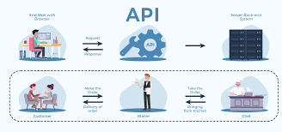

An **API** is a set of rules and protocols that allows different software applications to communicate with each other. It defines how requests and responses should be formatted and how the client and server should interact.

APIs can be:

* **Web APIs** (like REST, GraphQL, SOAP)
* **Library APIs** (for calling functions within a programming library)
* **Operating System APIs** (for interacting with OS-level functionality)

APIs can use various communication protocols (like HTTP, TCP, or others) and data formats (JSON, XML, etc.). So, an API doesn't have to be RESTful. It could be based on other architectural styles like SOAP, GraphQL, or RPC.

### REST API (Representational State Transfer API)

A **REST API** is a specific type of API that follows the principles of **REST** (Representational State Transfer), an architectural style for designing networked applications. REST APIs work over HTTP and use standard HTTP methods (GET, POST, PUT, DELETE) for operations.

Key things about REST APIs:

1. **Stateless**: Each request is independent and includes all necessary data.
2. **Resource-based**: Resources (such as users, products, etc.) are identified by URLs (e.g., /users/123).
3. **HTTP Methods**: Uses standard HTTP methods:
   * **GET** to retrieve data
   * **POST** to create data
   * **PUT/PATCH** to update data
   * **DELETE** to remove data
4. **Data Formats**: Often JSON or XML is used for sending and receiving data.

### Summary of Differences:

* **API** is a broad term that refers to any set of tools and protocols for communication between systems.
* **REST API** is a specific type of API that adheres to the principles of REST and typically uses HTTP.

**Fetch() method:**

The fetch() method is a modern web API that allows you to make network requests (such as HTTP requests) in JavaScript. It's used to request resources over the network and handles responses in a more flexible and promise-based way compared to older methods like XMLHttpRequest.

### Basic Syntax:

fetch(url, options)

ex:

fetch('https://api.example.com/data')

.then(response => response.json()) // Parse the JSON response

.then(data => {

console.log(data); // Use the parsed data

})

.catch(error => {

console.error('Error:', error); // Handle any errors

});

### Key Features of fetch():

1. **Returns a Promise**:
   * fetch() returns a **promise** that resolves to the Response object representing the response to the request. This means you can use .then() or async/await to handle the response asynchronously.
2. **Supports all HTTP methods**:
   * The default method is GET, but you can specify other HTTP methods like POST, PUT, DELETE, etc., by passing an options object.
3. **Handling Responses**:
   * Once you get a Response object, you can use methods like response.json(), response.text(), or response.blob() to process the response body.
   * Common methods:
     + .json(): Parses the response body as JSON.
     + .text(): Retrieves the response body as plain text.
     + .blob(): Retrieves the response body as a binary large object (e.g., image or video).
     + .status: The HTTP status code (e.g., 200 for success, 404 for not found).
     + .ok: A boolean indicating whether the response status code is in the range 200-299.

### What is response.json()?

response.json() is a method available on the Response object returned by the Fetch API. It is used to parse the body of the response as JSON (JavaScript Object Notation) format.

When you make a request to an API (or any server that returns a JSON response), the server sends back data in the form of a response body. If that body is JSON, you use response.json() to convert the raw text into a JavaScript object so you can work with it.

### How does it work?

When you make a network request (using fetch), the response comes back as a Response object. To get the actual data from that response, you need to convert the body to a usable format.

* The Response object contains methods to read the body in different formats, and json() is one of them.
* Calling response.json() **parses the response body** as JSON (if the body is valid JSON) and **returns a promise**.

**useEffect():**

useEffect=componentDidMount , componentDidUpdate and componentWillUnmount

The useEffect Hook allows you to perform side effects in your components.

**What are side effects in React?**

Side effects are not predictable because they are actions which are performed with the "outside world."

**Common side effects include:**

Making a request to an API for data from a backend server

To interact with browser APIs (that is, to use document or window directly)

Using unpredictable timing functions like setTimeout or setInterval

A side-effect can be any effect(programming logic) that is responsible for changing the state of your component. If the state changes, the component re-renders. For example, a typical side effect is making an API call and changing the local state of a component to store the API response data.

useEffect accepts two arguments. The second argument is optional.

**useEffect(<function>, <dependency>)**

useEffect works everytime return statement renders | useEffect() will work immediately application opens

useEffect(()=>{console.log('clicked')})

but if you want to use only once, use dependencies[]

if you use dependencies in useEffect 'clicked' message will display only in the begining of app.

but if you want to execute useEffect every time certain state renders then write below code

call state to dependencies=>[state]

useEffect(()=>console.log('hello'),[state]) =>executes everytime state updates

ex:

useEffect(()=>{

    console.log("Mounted...")

  },[data])

  const increment=()=>{

    setState(state+1)

  }

  const message=()=>{

    if(data=="react"){

    setData("hello")

    }else{

      setData("react")

    }

  }

-------------------------------------------------------------------

**24thMay**

Random user Api

Using images from API

Openweathermap API

------------------------------------------------------------------

Using bootstrap in React

Install bootstrap

npm i bootstrap

importing bootstrap:

import ‘../node_modules/bootstrap/dist/css/bootstrap.css’

-------------------------------------------------------------------

Task1: Dynamic styling

import './style.css'

const [style, setStyle] = useState('txt')

<h1 className={style}>css</h1>

function demo(){

if(style=='txt'){

setStyle('txt1')

}else{

setStyle('txt')

}

}

Task2:pic change with click

Bootstrap with react

Npm install bootstrap

Node_modules/bootstrap/dist/css/bootstrap.css

------------------------------------------------

**React component life cycles:**

Everything in this world follows a cycle, whether it’s plants, animals, or humans. They are born, they grow and they die, thus following a cycle. React components also follow a cycle. They are created (mounted), they are grown(updated), and they die (unmounting).This is nothing but called a **component lifecycle**.

A React component has three different phases in its lifecycle, including

**mounting,**

**updating, and**

**unmounting**.

Each phase has its own methods which are responsible for a particular stage in a component’s lifecycle. These methods are for class-based components, functional component has their own life cycle methods.

**Life cycle Methods of class component:**

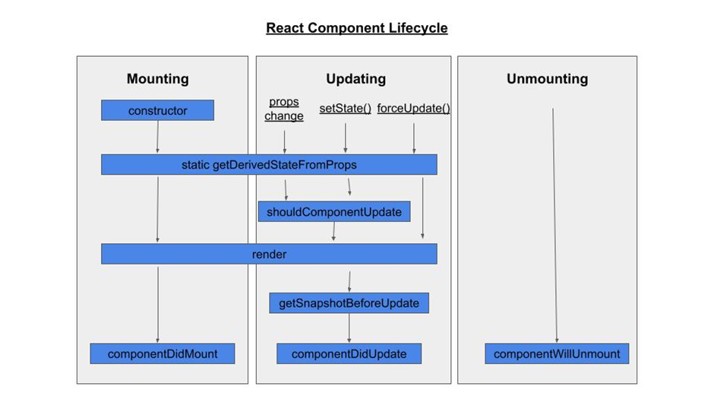

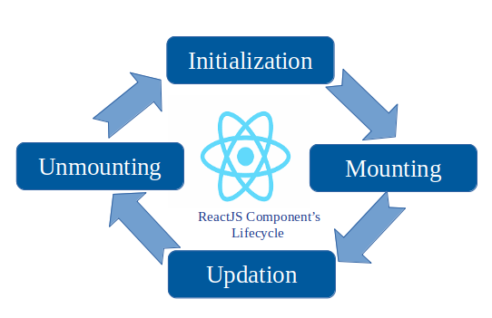

**useMemo() hook:**

The React useMemo Hook returns a memoized value.

Think of memoization as caching a value so that it does not need to be recalculated.

The useMemo Hook only runs when one of its dependencies update.

This can improve performance.

We use somany functions in every app. But most of the time unnecessary functions are called, which reduces performace. So we use useMemo to improve performance.

function multiply(){

return add*10

}

{multiply()}

=>add **** to console

function multiply(){

console.log("******")

return add*10

}

=>now execute , click both buttons one after other and show conlse

=>even though u added multiply to add state only, even

when u click minus also it show *****

=>that means unnessory some other functin executing

=>so use useMemo

const multiplication=useMemo(function multiply(){

console.log("******")

return add*10

},[add])

Ex:

import React, { useMemo } from 'react'

import { useState } from 'react'

export default function App() {

const [add, setAdd]=useState(0)

const [del, setDel]=useState(100)

const addition=()=>{

setAdd(add+1)

}

const deletion=()=>{

setDel(del-1)

}

// function multiply(){

// console.log("LPU")

// return add*10

// }

const multiplication=useMemo(function multiply(){

console.log("LPU")

return add*10

},[add])

return (

<div>

{add}

<h2>{multiplication}</h2>

<button onClick={addition}>Addition</button>

<br/>

{del}

<button onClick={deletion}>Substraction</button>

</div>

)

}

=>in above code we added only 'add' state so

========================

**Controlled Components and UnControlled Components:**

Controlled components are managed by React state,

while uncontrolled components are managed by the DOM.

**Controlled components:**

* **Form data**: React manages the form data
* **Predictability**: Controlled components are predictable because React manages the state
* **Validation**: Controlled components can validate form data as the user types
* **Use cases**: Controlled components are good for complex forms, real-time validation, and tight control over form values

<input type="text" value={city} onChange={(e)=>setCity(e.target.value)}/>

Or

You can call function:

<input type="text" value={state} onChange={handler}/>

**Uncontrolled components**

* **Form data**

The DOM manages the form data

* **Predictability**

Uncontrolled components are less predictable because form elements can change from external sources

* **Validation**

Uncontrolled components only validate form data after the form is submitted

* **Use cases**

Uncontrolled components are good for rapid prototyping, simple forms, and minimizing React's involvement

How to write uncontrolled components

* Use a ref to get form values from the DOM
* Don't write an event handler for every state update

Ex:useRef() hook:

const myRef=useRef()

console.log(myRef)

const handler=()=>{

alert(myRef.current.value);

}

<form onSubmit={handler}>

<input type="text" ref={myRef}/>

<button type="submit">submit</button>

</form>

inputElement.current.focus();

inputElement.current.style.color='red';

**Filter() method:**

The filter() method creates a new array filled with elements that pass a test provided by a function.

The filter() method does not execute the function for empty elements.

The filter() method does not change the original array.

**Includes() method:**

The includes() method returns true if an array contains a specified value.

The includes() method returns false if the value is not found.

The includes() method is case sensitive.

{state.filter(item=>item.name.includes('P')).map(item=><li>{item.name}</li>)}

Ex:

import data from './data.json'

const [state,setState]=useState(data)

const [search, setSearch]=useState()

<input type="text" placeholder='search ....' value={search}

    onChange={(e)=>setSearch(e.target.value)}/>

{state.filter(item=>item.name.includes(search))

.map(item=><li>{item.name}</li>)}

**25th May:**

**Single Page Application(SPA):**

A single-page application (SPA) is a web app that loads a single web page and then updates it with new data from the server. This makes the app feel more like a native app, with faster transitions between pages.

**Routing**:

In a single-page React Application, routing refers to the process of navigating between different pages without triggering a full page reload. The application initially loads a single HTML page. Then, it dynamically renders different components based on user interaction.

Need to install=> react-router-dom

npm I react-router-dom

React-router-dom contains in built component

BrowserRouter

Routes

Route

Link

<BrowserRouter>=> We wrap our content first with <BrowserRouter>.

<Routes>=> Then we define our <Routes>. An application can have multiple <Routes>

<Route> =><Route> s can be nested. The <Route> has a path of / and renders the component.

import { BrowserRouter,Routes,Route } from "react-router-dom";

<BrowserRouter>

<Routes>

<Route path='/about' element={<h1>About Us Page</h1>} />

</Routes>

</BrowserRouter>

<a href=”/”> home</a>

<a href=”/about”> about</a>

<Link to=”/”>Home</Link>

<Link to=”/about”> About </Link>

What is Axios in React for?

Axios, which is a popular library is mainly used to send asynchronous HTTP requests to REST endpoints. This library is very useful to perform CRUD operations. This popular library is used to communicate with the backend.

function handler(){

axios.get('https://randomuser.me/api/?results=50')

.then((res)=>{console.log(res)

console.log(res.data.results)

}) }

Ex2:

  useEffect(()=>{

         axios.get("https://jsonplaceholder.typicode.com/todos")

      .then(data => console.log(data.data))

      .catch(error => console.log(error));

  })

**useContext():**

Why use context in React?

Context, in React, is a way to pass data down through a component tree without having to pass props down through every level. This can be very helpful since this allows us to share data between components that are not directly related to each other (e.g., between sibling components).

createContext :

const data = createContext()

### Context Provider

Wrap child components in the Context Provider and supply the state value.

<data.Provider value={fname}>

<CompC />

</data.Provider>

### useContext Hook

const user = useContext(data);

<h1>{user}

**Weather API:**

  useEffect(()=>{

    fetch(`https://api.openweathermap.org/data/2.5/weather?q=Delhi&appid=e849ec378296aae22dc243a8b9d84def`)

    .then((res)=>res.json())

    .then((json)=>setState(json.main.temp))

  },[])

Todo List ex:

import { useState } from "react";

const App = () => {

const [todo, setTodo] = useState("");

const [todos, setTodos] = useState([]);

const addTodo = () => {

setTodos([...todos, todo]);

setTodo("");

};

const deleteHandler = (indexValue) =>{

const newTodos = todos.filter((todo,index) => index !== indexValue);

setTodos(newTodos);

}

return (

<div >

<h1>React Todo App</h1>

<div >

<input type="text" name="todo" value={todo} placeholder="Create a new todo" onChange={(e) => { setTodo(e.target.value); }} />

<button onClick={addTodo}> Add </button>

{todos.map((x,index)=><li key={index}> {x} <button onClick={()=>deleteHandler(index)}>Delete</button></li> )}

</div> </div>

);};

export default App

useRef():

import { useRef} from 'react'

function App() {

const inputElement = useRef();

const focusInput = () => {

inputElement.current.focus();

inputElement.current.style.color='red';

};

return (

<>

<input type="text" ref={inputElement} />

<button onClick={focusInput}>Focus Input</button>

</>

)

}

export default App

**Higher-order Component(HOCs):**

===============================

Higher-order components (HOCs) are a powerful feature of the React library. They allow you to reuse component logic across multiple components. In React, a higher-order component is a function that takes a component as an argument and returns a new component that wraps the original component.

Instead of doing it manually, you can use a "robot" that will do it automatically for you. This robot is a Higher-Order Component (HOC), a function that takes a component (your pastry) and returns your pastry with additional functionalities or features (in this case, a label indicating its type and ingredients)

Hoc:

import React from 'react'

const clr={

    color:'red',

    background:'yellow'

}

export default function Hoc(props) {

  return (

<h3 style={clr}><props.cmp/></h3>

  )

}

App.jsx

import React from 'react'

import Add from './Add'

import Minus from './Minus'

import Hoc from './Hoc'

export default function App() {

  return (

    <div>

    <Hoc cmp={Add}/>

    <Hoc cmp={Minus}/>

       </div>

  )

}

**Lazy Loading:**

Lazy loading is one of the most common design patterns used in web and mobile development. It is widely used with frameworks like Angular and React to increase an application’s performance by reducing initial loading time.

First, they use the power of code splitting and dynamic imports to allow developers to implement lazy loading for their applications easily.

React.lazy() allows developers to easily create components with dynamic imports and render them as normal components. When the component is rendered, it will automatically load the bundle that contains the rendered component.

You need to provide a single input parameter to call React.lazy(). It accepts a function as an input parameter, and that function should return a promise after loading the component using import(). Finally, the returned promise from React.lazy() will give you a module with a default export containing the React component.

The following code shows how to use the React.lazy() function.

// Without React.lazy()

import AboutComponent from './AboutComponent ';

// With React.lazy()

const AboutComponent = React.lazy(() => import('./AboutComponent '));

AboutComponent.jsx:

import React from 'react'

export default function AboutComponent() {

  return (

    <div>

      <h1>AboutComponent</h1>

      <h1>AboutComponent</h1>

      <h1>AboutComponent</h1>

      <h1>AboutComponent</h1>

      <h1>AboutComponent</h1>

      <h1>AboutComponent</h1>

    </div>

  )

}

**React.Suspense**

When we use lazy loading, components are rendered as we navigate. So, we need to have a placeholder for those components until they are loaded. As a solution, React.Suspense was introduced, and it acts as a wrapper for the lazy components.

import React, { Suspense } from "react";

const AboutComponent = React.lazy(() => import('./AboutComponent'));

const App = () => (

    <div>

      <Suspense fallback = {

<div> Please Wait... </div> } >

      <AboutComponent />

      </Suspense>

    </div>

);

export default App

=======

**REDUX:**

import React from 'react';

// import './App.css';

import { legacy_createStore as createStore} from 'redux'

const initialState="Hello World"

const reducer=(state=initialState, action)=>{

return state

}

const store=createStore(reducer)

console.log(store.getState())

function App(){

return(

<div>

<h1> Redux is no nice {store.getState()}</h1>

</div>

)

}

export default App

ex:2

import React from "react";

import './Store'

const App = () => {

return (

<>

<h1>Redux </h1>

</>

)

}

export default App

store.jsx:

import { createStore } from "redux";

//store

//action

//reducer

const increment=()=>{

return{

type:"INCREMENT"

}

}

const decrement=()=>{

return{

type:"DECREMENT"

}

}

const counter=(state=100, action)=>{

switch(action.type){

case "INCREMENT":

return state+1

case "DECREMENT":

return state-1

default:

return state

}

}

const store=createStore(counter)

console.log(store.getState())

//DISPATCH

store.dispatch(increment())

console.log(store.getState())

store.dispatch(decrement())

console.log(store.getState())

**Redux Terminology:**

**Action:** Actions are JavaScript object that contains information. Actions are the only source of information for the store. It basically carries a payload of information from the application to the store. It only tells us what has happened. Actions have a type property that they must include as type property tells what kind of action to perform. Action can also contain the payload(data field in the action) to describe the action.

Syntax:

const action = {

type: "SET_USER_FIRST_NAME",

payload: "Alex"

}

In the syntax, the Action object has two properties. The first property is “type property” it should be defined in string constraint and It is compulsory to include the type property in the object. The second one is “payload”, Payload stores the additional information about what happened. It is not a compulsion to include “payload” in the object. It is entirely up to you but we should always try to pass only the necessary information to the action object and try to keep it as light as possible.

As said above, action is the only source of information for the store.

**Store:**

The store is the object which holds the state of the application. See, it contains the state of the components which need to be passed to other components. The store makes this passing along much easier as we no longer need to maintain a state inside a parent component in order to pass the same to its children components.

Functions associated with Store:

**createStore():** This method is used to create a store.

const store = createStore()

**dispatch(action):** To change the state, we need to call the store.dispatch() and pass in an action object.

store.dispatch({ type: 'Action' })

**getState():**

This method is for getting the current state of the store. Basically, after dispatching the action, the store will run its reducer function (a pure function that takes the current state and action and returns the new state, and tell the store how to do it). and save the new value inside it. Then we will call the getState() method to retrieve the updated value of the application.

Action Creators

Action creators are the function that creates actions. So actions are the information (Objects) and action creator are functions that return these actions. These functions help to achieve reusability.

// Creating Action creator

function AddToDo(task) {

return { type: 'ADD_TASK', task: task }

}

// Dispatching

store.dispatch(AddToDo('anything'));

**Provider:**

Provider will serve as the component bridge between the Redux store and our entire app,

wrap the App component with this component provided to us from the react-redux library.

This component will have a property called store , and the value of this property is going the be the entire Redux store contained inside a variable also called store .

<Provider store={store}>

<App/>

</Provider>

**useSelector and useDispatch:**

useSelector and useDispatch are a set of hooks to use as alternatives to the existing connect() higher-order component. The equivalent of map state to props is useSelector. It takes in a function argument that returns the part of the state that you want. The equivalent of map dispatch to props is useDispatch. We can invoke useDispatch and store it to a variable, dispatch. Dispatch will work with the allActions imported from the actions folder.

**NODEJS Introduction**

javascript is a browser language.

javascript code interpreted and converted in to machine language by javascript engine

javascript engine will convert user readable language to machine language

chrome and internet explorer uses v8 engine=>v8 famous

v8 is faster, means js is faster

Nodejs:

nodejs is a javascript runtime environment which uses v8 engine

The runtime environment is **the environment in which a program or application is executed**. It's the hardware and software infrastructure that supports the running of a particular codebase in real time.

**“Nodejs is a javascript running on the server side”**

Node js is javascript with additional server side features

it will run out side of browser

No Database connectivity in javascript

but with nodejs database connectivity is possible because nodejs is server side.

## What is Node.js?

Node.js is an open-source, Javascript *runtime environment* on Chrome’s V8 that lets you effortlessly develop fast and scalable web applications. It utilizes an event-driven, non-blocking I/O model that makes it lightweight, efficient and excellent for data-intensive real-time applications that run across shared devices.

Node. js is primarily used **for non-blocking, event-driven servers**, due to its single-threaded nature. It's used for traditional web sites and back-end API services, but was designed with real-time, push-based architectures in mind.

What is an example of event-driven programming?

[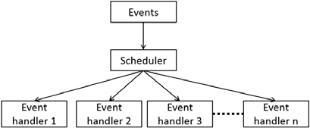](https://www.google.com/search?rlz=1C1CHBD_enIN996IN996&sxsrf=ALiCzsZ3BBJziVvdCojsCoe-Nv-eIChpXw:1654011270159&q=What+is+an+example+of+event-driven+programming?&tbm=isch&source=iu&ictx=1&vet=1&fir=qAWaFjHfSuNILM%252CxmkRLJTwMqZwEM%252C_&usg=AI4_-kTAfYE1S0hEPCQSfhKmT7Y8smJuLA&sa=X&ved=2ahUKEwitjtmRiIr4AhX0UGwGHT8QAEQQ9QF6BAhUEAE" \l "imgrc=qAWaFjHfSuNILM)

Event-driven programming is a programming paradigm in which the flow of program execution is determined by events - for example **a user action such as a mouse click, key press, or a message from the operating system or another program**

Javascript and Node.js, the code operates faster in server-to-client direction. This enhances the performance ability of the web applications to the next level. To be more precise, web application development in Node.js ensures a steady and secure non-blocking I/O model, simplifying the code beautifully.

Node.js runs over Google’s  V8 Javascript engine, where web applications are event-based in an **asynchronous** manner. Node.js platform uses a “*single-threaded event loop*.”

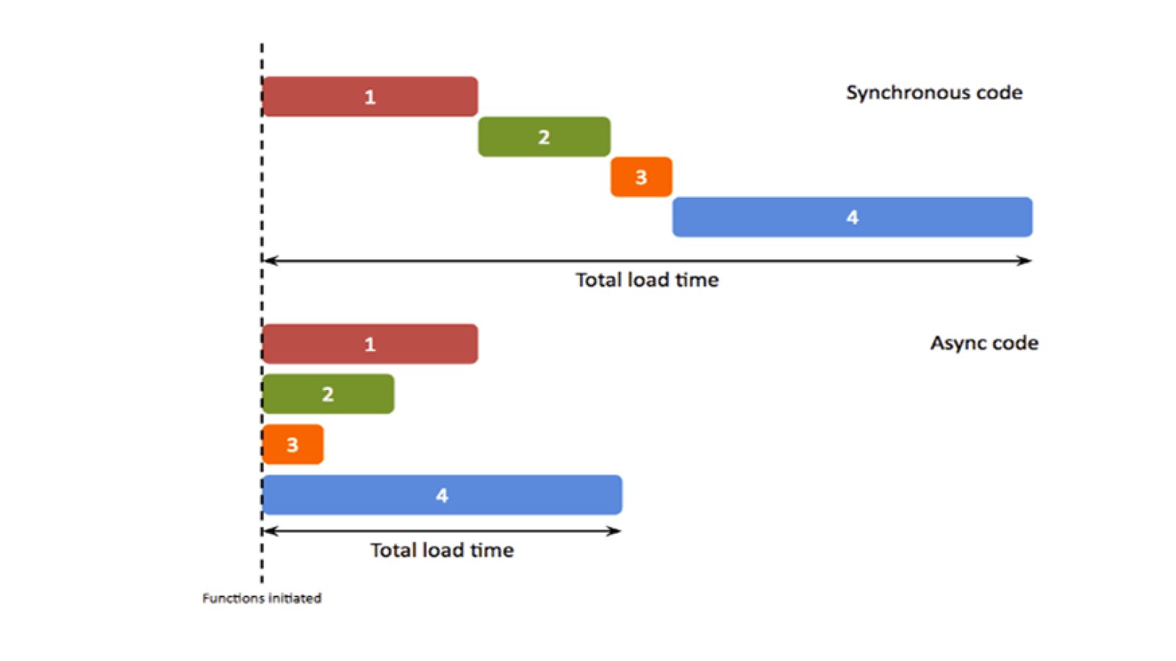

Unlike the traditional web-serving technique, where each request creates new thread cramping up the system RAM, Node.js operates on a single thread. This enables it to support thousands of concurrent connection handling event loops

API(Application programming Interface) can be developed using NodeJs.

Javascript can be used in browser, javascript can be used in server using nodejs modules

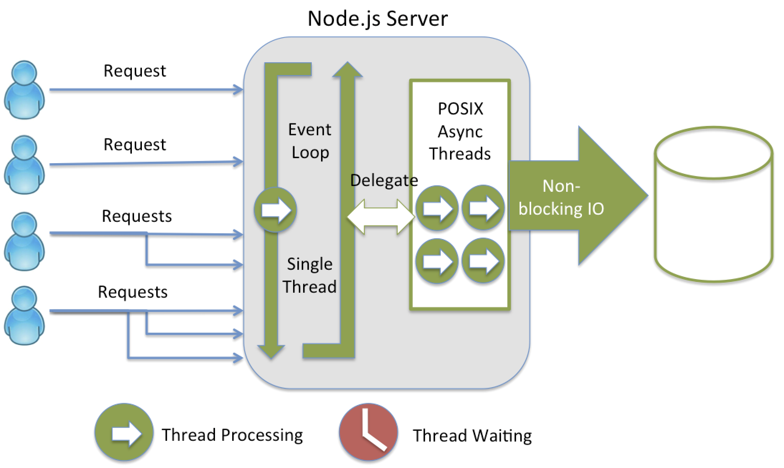

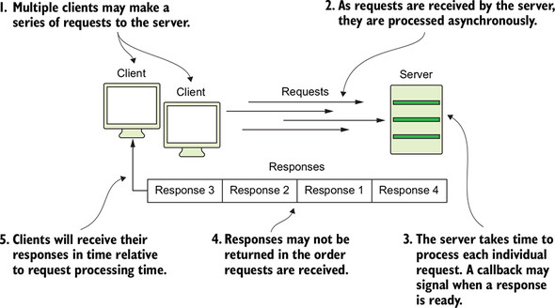

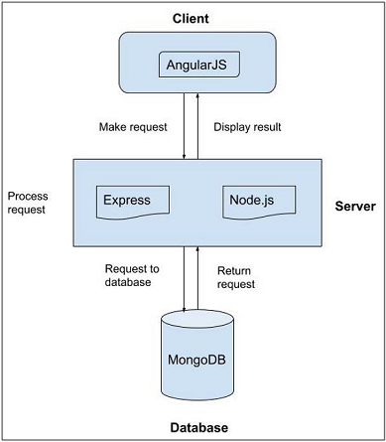

## CALL BACK:

What is call back in javascript / node js?

A javascript / nodejs callback is **a function which is to be executed after another function has finished execution**. A more formal definition would be - Any function that is passed as an argument to another function so that it can be executed in that other function is called as a callback function.

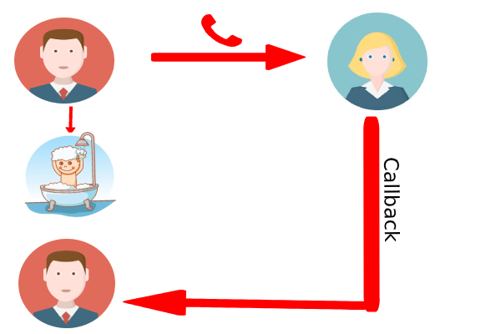

## What is npm?

npm stands for Node Package Manager. It’s a [**library**](https://careerfoundry.com/en/blog/web-development/programming-library-guide/) and **registry** for JavaScript software packages.

npm also has command-line tools to help you install the different packages and manage their dependencies.

[npm is free](https://www.npmjs.com/) and relied on by over 11 million developers worldwide. You could say it’s kind of a big deal. They’re open-source and have become the center of Javascript code sharing. There are more than a million packages available on npm.

In short, npm is:

* an online repository for the publishing of open-source Node.js projects
* a command-line utility for interacting with said repository helping with installing packages and managing package versions and dependencies

## Why use npm?

It’s certainly possible to manage your project’s dependencies yourself. As your project grows, though, this can become a herculean task.

This is where a package manager like npm comes in. npm solves this problem by handling dependency and package management for your project.

You define all your project’s dependencies inside your package.json file. Anytime you or a team member needs to get started with your project, all they have to do is run **npm install**.

This will immediately install all the necessary dependencies for your project. In the package.json file, you can also specify which versions your project depends upon. This is useful to prevent updates from these packages from breaking your project.

## What is a package.json?

A package.json file is created by your package manager (in this case npm) and exists at the root of a project in JavaScript/Node. To generate a package.json file you can run **npm init**. You’ll then be asked to fill out some metadata for your project such as:

* Name – your project’s name
* Version – current version in major.minor.patch format (1.0.0, 1.2.3, etc.)
* Description – description of the project
* License – the license your project is under, so people know how they are allowed to use it. Full list of licenses [on the Software License Data Exchange site](https://spdx.org/licenses/).

The package.json file is in JSON format and is used for managing the project’s dependencies, scripts, versions, etc. Here’s a simple example:

{

"name": "My cool project",

"version": "1.0.0",

"description": "",

"main": "index.js",

"directories": {

"test": "test"

},

"scripts": {

"test": "jest",

},

"license": "ISC"

}

**Modules**

In Node.js, **Modules** are the blocks of encapsulated code that communicates with an external application on the basis of their related functionality.

Modules can be a single file or a collection of multiples files/folders.

The reason programmers are heavily reliant on modules is because of their re-usability as well as the ability to break down a complex piece of code into manageable chunks.

**Modules are of three types:**

* Core Modules
* local Modules
* Third-party Modules

**Core Modules:** Node.js has many built-in modules that are part of the platform and comes with Node.js installation. These modules can be loaded into the program by using the **require** function.

Loading Core Modules

**require() function:**

Node.js follows the CommonJS module system, and the built-in **require** function is the easiest way to include modules that exist in separate files. The basic functionality of require is that it reads a JavaScript file, executes the file, and then proceeds to return the exports object.

In order to use Node.js core or NPM modules, you first need to import it using require() function as shown below.

**Syntax:**

var module = require('module_name');

| Core Module | Description |
| --- | --- |
| http | http module includes classes, methods and events to create Node.js http server. |
| [url](https://nodejs.org/api/url.html) | url module includes methods for URL resolution and parsing. |
| [querystring](https://nodejs.org/api/querystring.html) | querystring module includes methods to deal with query string. |
| path | path module includes methods to deal with file paths. |
| [fs](https://nodejs.org/api/fs.html) | fs module includes classes, methods, and events to work with file I/O. |
| [util](https://nodejs.org/api/util.html) | util module includes utility functions useful for programmers. |

Example of http module to create a web server

var http = require('http');

var server = http.createServer(function(req, res){

//write code here

});

server.listen(5000);

**Local Modules:** Unlike built-in and external modules, local modules are created locally in your Node.js application.

These modules include different functionalities of your application in separate files and folders. You can also package it and distribute it via NPM, so that Node.js community can use it.

For example, if you need to connect to sql server / MongoDB and fetch data then you can create a module for it, which can be reused in your application.

a.js

console.log("Welcome to modules")

b.js

const main=require('./a')

--

C1.js:

function demo(a,b){

var c=a+b

console.log(c)

}

demo(10,20)

var college="CBIT"

module.exports.data=college

--

C2.js

const main=require('./c1')

console.log(main.data)

**Third-party modules:** Third-party modules are modules that are available online using the Node Package Manager(NPM). These modules can be installed in the project folder or globally. Some of the popular third-party modules are mongoose, express, angular, and react.

**Example:**

* npm install express
* npm install mongoose
* npm install -g @angular/cli

**Global objects**

_ _dirname

_ _filename

require

exports

console

console.log(__dirname) /console.log(__filename)

**File System Module**

readFile() / appendFile() / unlink() /mkdir / rmdir / rename methods

The Node. js **file system module** allows you to work with the file system on your computer.

To include the File System module, use the require() method: var fs = require('fs');

The **fs.readFile()** method is an inbuilt method which is used to read the file. This method read the entire file into buffer. To load the **fs module** we use require() method.

var http = require('http');  
var fs = require('fs');  
http.createServer(function (req, res) {  
**fs.readFile(hello.txt, function(err, data) {**    res.writeHead(200, {'Content-Type': 'text/html'});  
    res.write(data);  
    return res.end();  
  });  
}).listen(8080);

The **fs.appendFile() method** is used to asynchronously append the given data to a file. A new file is created if it does not exist. The options parameter can be used to modify the behavior of the operation.

var fs = require('fs');

fs.appendFile('hello.txt', 'Hello content! appended', function (err) {

  if (err) throw err;

  console.log('Saved!');

});

**unlink() method** is used to delete a file

const fs=require("fs");

fs.unlink(__dirname+"/hello.txt", (err, data)=>{

    if(err) throw err;

    console.log("File deleted"+data)

});

**rename() method:**

**copyFile() method:**

**mkdir() method**

**rmdir() method**

Stats:

The stat method in the fs module allows us to fetch details about any file regardless of the file type. All we need to do is specify the path leading to that file, and once the method loads the file details, a callback function will be returned. We’ll pass that callback function two arguments: first, an error message, and, second, an object containing the file stats.

### Stat Object Properties:

* **stats.isFile():** Returns true if the path is a file.
* **stats.isDirectory():**Returns true if the path is a directory.
* **stats.size:**The size of the file in bytes.

const fs = require('fs');

fs.stat("test.txt", (error, stats) => {

    if(!error){

        console.log("file exists")

    }else{

        console.log("not exists")

    }

      });

Sync and Async example

const fs=require('fs')

console.log('Program Started...')

const data=fs.readFileSync('demo.txt')

console.log(data.toString())

console.log('Program ended...')

Async:

const fs=require('fs')

console.log('Program Started...')

fs.readFile('demo.txt','utf8',(err,data)=>{

    if(!err){

        console.log(data)

    }

})

console.log('Program Ended...')

**os Module:**

freemem()

freemem()

totalmem()

userInfo()

tmpdir()

release()

**http module**==> to create server we use http core module

**server.listen()** ==>The server.listen() is an inbuilt application programming interface of class Socket within module which is used to start the server to listen the encrypted connection.

const server.listen([port[, host[, backlog]]][, callback])

**res.write()**

**res.end()**

**npm I nodemon**

ex1:

const http=require('http')

http.createServer((req,res)=>{

    res.write("Welcome to server code")

    res.end()

}).listen(3000,()=>console.log(

    'Server started.'))

Ex2:

const http=require('http')

const fs=require('fs')

http.createServer((req,res)=>{

    res.writeHead(200,{

        //'Content-type':'text/plain'

        'Content-type':'text/html'

    })

    fs.readFile(__dirname+'/web.html',(err,data)=>{

        res.write(data)

        res.end()

    })

}).listen(3000,()=>console.log('server started..'))

Ex:

const http=require('http')

http.createServer((req,res)=>{

    if(req.url=='/'){

        res.write("Home page")

        res.end()

    }else if(req.url=='/about'){

        res.write("Aboutus page")

        res.end()

    }else if(req.url=='/contact'){

        res.write("Contact Us page")

        res.end()

    }else{

        res.write('invalid page')

        res.end()

    }

}).listen(3000,()=>console.log('server started...'))

Ex:

const http=require('http')

const fs=require('fs')

http.createServer((req,res)=>{

    if(req.url=='/'){

        fs.readFile(__dirname+'/Home.html',

        (err,data)=>{

            res.write(data)

            res.end()

        })

    }else if(req.url=='/about'){

        fs.readFile(__dirname+'/About.html',

        (err,data)=>{

            res.write(data)

            res.end()

        })

    }else if(req.url=='/contact'){

        fs.readFile(__dirname+'/Contact.html',

        (err,data)=>{

            res.write(data)

            res.end()

        })

    }else{

        res.write('invalid file')

        res.end()

    }

}).listen(3000,()=>console.log('server started...'))

### HTTP response status codes

Code Constant Reason Phrase

100 CONTINUE Continue

102 PROCESSING Processing

200 OK OK

201 CREATED Created

202 ACCEPTED Accepted

400 BAD_REQUEST Bad Request

401 UNAUTHORIZED Unauthorized

402 PAYMENT_REQUIRED Payment Required

403 FORBIDDEN Forbidden

404 NOT_FOUND Not Found

**Events and Event emitter:**

**Node.js** is built on an event-driven architecture that allows you to build highly scalable applications. Understanding the event-driven nature of Node.js and how to work with events is important for building efficient and responsive applications.

### EventEmitter Class

At the core of the Node.js event system is the EventEmitter class. This class allows objects to emit named events that can be listened to by other parts of your application. It is included in the built-in events module.

### Key Features of EventEmitter:

* **Event Registration:**You can register listeners for specific events using the on() method.
* **Event Emission:** Use the emit() method to trigger an event and call all registered listeners for that event.
* **Asynchronous Execution:** Listeners can execute asynchronously, allowing other operations to continue while waiting for events.

**Syntax:**

const EventEmitter=require('events');

var eventEmitter=new EventEmitter();

## Working with Events in Node.js

### Step 1: Importing the Events Module

To start using events in your application, you need to import the events module and create an instance of the EventEmitter class.

const EventEmitter = require('events');

const myEmitter = new EventEmitter();

### Step 2: Registering Event Listeners

You can register listeners for specific events using the on() method. The first argument is the event name, and the second argument is the callback function to be executed when the event is emitted.

myEmitter.on('event', () => {  
 console.log('An event occurred!');  
});

### Step 3: Emitting Events

To trigger an event, use the emit() method with the event name as the first argument.

myEmitter.emit('event'); // Output: An event occurred!

const eventEmitter=require('events')

const event=new eventEmitter

event.on('test',()=>{

    console.log("event fired..")

})

event.emit('test')

# Node.js Streams

Node.js streams are a key part of handling I/O operations efficiently. They provide a way to read or write data continuously, allowing for efficient data processing, manipulation, and transfer.\

## Node.js Streams

The stream module in Node.js provides an abstraction for working with streaming data. Streams are a powerful feature that allows handling data in chunks rather than loading it all at once, which is efficient for both memory usage and performance.

The official Node.js documentation defines streams as “A stream is an abstract interface for working with streaming data in Node.js.” The stream module provides an API for implementing the stream interface. Examples of the stream object in Node.js can be a request to an HTTP server and process.stdout are both stream instances. In short, Streams are objects in Node.js that lets the user read data from a source or write data to a destination in a continuous manner.

### ****Accessing Streams:****

const stream = require('stream');

**Note:**What makes streams powerful while dealing with large amounts of data is that instead of reading a file into memory all at once, streams actually read chunks of data, processing its content data without keeping it all in memory.

### ****Advantages of Streams over other data handling methods:****

* **Time Efficient:** We don’t have to wait until entire file has been transmitted. We can start processing data as soon as we have it.
* **Memory Efficient:** We don’t have to load huge amount of data in memory before we start processing.

### ****Types of Streams in Node.js:****

There are namely four types of streams in Node.js.

1. **Writable:** We can write data to these streams. **e.g.,**fs.createWriteStream().
2. **Readable:** We can read data from these streams. **e.g.,** fs.createReadStream().
3. **Duplex:** Streams that are both, Writable as well as Readable. **e.g.,**net.socket.
4. **Transform:** Streams that can modify or transform the data as it is written and read. **e.g.,**zlib.createDeflate.

Ex: ReadStream:

var fs=require('fs')

var myReadStream=fs.createReadStream(

    __dirname+'/demo.txt','utf8')

myReadStream.on('data',function(chunk){

console.log("*********** new chunk received***********")

console.log(chunk)

})

**highWaterMark:**

**What is the highWaterMark in node?**

highWaterMark property returns the total number of bytes that can be contained in the internal queue before backpressure is applied.

Ex:2

var fs=require('fs')

var myReadStream=fs.createReadStream(__dirname+'/demo.txt',

{

encoding:'utf8',

highWaterMark:30,

// start:0,

// end:200

})

myReadStream.on('data',function(chunk){

console.log("New Chunk "+chunk)

})

**Ex3: Write Stream / createWriteStream**

const fs=require('fs')

const file=fs.createWriteStream('test4.txt')

file.write("hello")

file.end('end')

----

var fs=require('fs')

var myReadStream=fs.createReadStream(__dirname+'/demo.txt','utf8')

var myWriteStream=fs.createWriteStream(__dirname+'/demo1.txt')

myReadStream.on('data',function(chunk){

console.log("new chunk received")

myWriteStream.write(chunk)

})

Ex4:

const fs = require('fs');

const server = require('http').createServer();

server.on('request', (req, res) => {

const src = fs.createReadStream('./demo.txt');

src.pipe(res);

});

server.listen(8000);

**url module:**

The NodeJS URL module provides us with utilities for the resolution and parsing of the URL.

const myURL = new URL('https://www.site.com/index.htm');

console.log(myURL.href);

host=>Used to get and set the host portion of the URL.

hostname=>Used to get and set the hostname portion of the specified URL .

href=>Used to get and set the serialized URL.

origin=>Used to get the read-only serialization of the URL’s origin.

password=>used to get and set the password portion of the given URL.

pathname=>Used to get and set the pathname portion of the given URL.

port=>Used to set and get the port portion of the provided URL.

protocol=>Used to get and set the protocol portion of the specified URL.

search=>Used to get and set the serialized query portion of the URL.

username=>Used to get and set the username of the provided URL.

const url=require('url')

const myURL = new URL('https://www.site.com/index.htm');

//console.log(myURL.href);

//console.log(myURL.host);

console.log(myURL.port);

Reading JSON

stringify():

============

A common use of JSON is to exchange data to/from a web server. When sending data to a web server, the data has to be a string.

const data={"name":"sudhakar","email":"ss@gmail.com","age":30}

res.write(JSON.stringify(data))

==============

Reading External data:

---------------------

const data=[

{name:'Sudhakar',email:'ss@gmail.com',age:30},

{name:'Ravi',email:'ss@gmail.com',age:30},

{name:'Bhuvi',email:'ss@gmail.com',age:30},

{name:'Mahi',email:'ss@gmail.com',age:30},

{name:'Sahi',email:'ss@gmail.com',age:30},

]

module.exports=data

const data=require('./source')

res.writeHead(200,{'Content-Type':'application\json'})

res.write(JSON.stringify(data))

===========================

**stringfy() and parse():**

**What is the difference between parse and stringify?**

**parse()** is used to convert JSON data into a JavaScript object , to make it accessible and modifiable with in the JavaScript code.

**JSON.stringify()** is used to convert a JavaScript object into a JSON formatted string, that is usually used to send data onto the server, or transmitting it onto the network.

**object to json:**

-------------------

const obj={

name:'Anil',

age:22,

place:'Hyderabad'

}

console.log(obj.name)

const json=JSON.stringify(obj)

console.log(json)

console.log(json.name)

=======================

**JSON TO OBJECT:**

parse:

-------

JSON parsing is the process of converting a JSON object in text format to a Javascript object that can be used inside a program. In Javascript, the standard way to do this is by using the method JSON.

const txt = '{"name":"John", "age":30, "city":"New York"}'

const obj = JSON.parse(txt);

console.log(obj)

ex:

external json file:data.json

[{

    "name":"Ravi",

    "place":"Proddatur",

    "age":30

}]

const http=require('http')

const data=require('./data)

http.createServer((req,res)=>{

    res.writeHead(200,

        {'Content-Type':'application\json'})

    res.write(JSON.stringify(data))

    res.end()

}).listen(3000,()=>console.log("Server started...") )

# EXPRESS:

Express is a node js web application framework that provides broad features for building web and mobile applications.

It is used to build a single page, multipage, and hybrid web application.

It's a layer built on the top of the Node js that helps manage servers and routes.

**Why Express JS?**

----------------

Express was created to make APIs and web applications with ease,

It saves a lot of coding time almost by half and still makes web and mobile applications are efficient.

Another reason for using express is that it is written in javascript as javascript is an easy language even if you don't have a previous

knowledge of any language. Express lets so many new developers enter the field of web development.

The reason behind creating an express framework for node js is:

1. Time-efficient
2. Fast
3. Economical
4. Easy to learn
5. Asynchronous

**Installing Express:**

====================

**1)Initialise npm**

npm init

=>This command prompts you for a number of things, such as the name and version of your application. For now, you can simply hit RETURN to accept the defaults for most of them

**2) Install express**

npm install express

Methods in Express

=>send() method

=>sendFile() method

**GET and POST**

**GET** and POST both are two common HTTP requests used for building REST API's.

**GET** requests are used to send only limited amount of data because data is sent into header while **POST** requests are used to send large amount of data because data is sent in the body.

Express.js facilitates you to handle GET and POST requests using the instance of express

**API(Application programming Interface)**

Symple example of api:

const express=require("express");

const App=express()  //creates express application

App.get("/people",function(req,res){

    res.send("Hello people");

});

App.listen(3000);

**One more example of Fetching data in JSON(javascript object notation) format:**

const express=require("express");

const App=express()  //creates express application

App.get("/people",function(req,res){

    res.json({people:[{name:"Sudhakar"}]});

});

App.listen(3000);

Get method facilitates you to send only limited amount of data because data is sent in the header. It is not secure because data is visible in URL bar.

**Routing** refers to how an application’s endpoints (URIs) respond to client requests.

Web frameworks provide resources such as HTML pages, scripts, images, etc. at different routes.

You define routing using methods of the Express app object that correspond to HTTP methods; for example, app.get() to handle GET requests and app.post to handle POST requests.

var express = require('express')

var app = express()

// respond with "hello world" when a GET request is made to the homepage

app.get('/', function (req, res) {

res.send('hello world')

})

app.listen(3000)

**req.query:**

**req.query** is an object containing a set of key-value pairs representing the query parameters of the URL. This object is used to get the values of query parameters, which are appended to the end of the URL after a question mark.

For example, in the URL localhost:3000?name="sudhakar"

localhost:3000?name="sudhakar"

app.get('/data',(req,res)=>{

res.send("Hello "+req.query.name)

}

=======================================================

# Middleware in Express

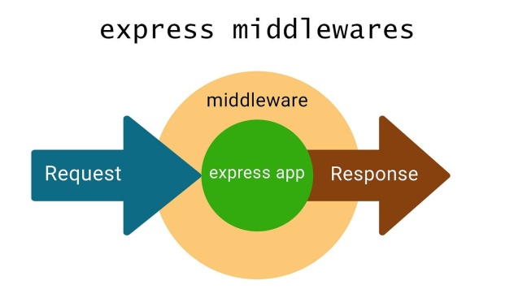

Express is a widely used Node.js framework known for its simplicity and flexibility in building web applications and APIs. One of its core features is middleware in Express, which plays an important role in handling requests, responses, and routing.

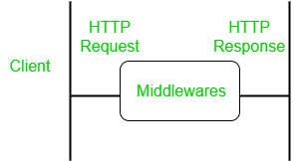

*Middleware working*

## What is Middleware in Express JS?

Middleware is a request handler that allows you to intercept and manipulate requests and responses before they reach route handlers. They are the functions that are invoked by the [Express.js](https://www.geeksforgeeks.org/express-js/) routing layer.

It is a flexible tool that helps add functionalities like logging, authentication, error handling, and more to Express applications.

### ****Syntax****

The basic syntax for the middleware functions is

app.get(path, (req, res, next) => {}, (req, res) => {})

Middleware functions take 3 arguments: the **request object**, the **response object**, and the **next function** in the application’s request-response cycle, i.e., two objects and one function.

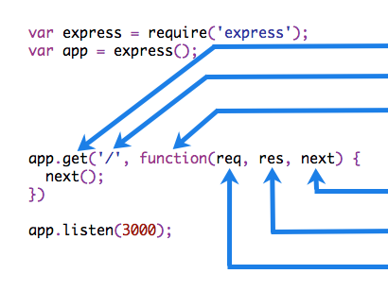

**Example of middleware validation:**

const express=require('express')

const app=express()

const validator=(req,res,next)=>{

    if(!req.query.age){

        res.send("Age is required..")

    }else if(req.query.age<18){

        res.send("Age should be above 18")

    }else{

        next()

    }

}

app.get('/',(req,res)=>{

    res.send("welcome")

})

app.get('/about',(req,res)=>{

    res.send("About us page content")

})

app.use(validator)

app.get('/contact',(req,res)=>{

    res.send("Contact us page here")

})

app.listen(3000,()=>console.log("server started..."))

**Middleware (Static files in Express)**

**express.static** is a built-in middleware function in express

What are static files in Express?

Static files are those files whose data are the same and whose content is constant and does not change, like a CSS file, images, or videos.

To serve static files such as images, CSS files, and JavaScript files, use the express.static built-in middleware function in Express.

express.static(root,[options])

app.use(express.static('public'))

const express=require("express");

const app=express();

app.use(express.static('public'))

app.get("/",(req, res)=>{

    res.sendFile(__dirname + "/index.html");

});

app.get("/users",(req, res)=>{

    res.send("User's page");

});

app.listen(3000,()=>console.log("server started"));

Index.html

<body>

    <h1>hello page</h1>

    <img src="pic.png"/>

 </body>

**body parser:**

Body parser middleware is an essential component in Express applications. It processes incoming request bodies, making it easier to handle POST and PUT requests. By parsing the body of an HTTP request and attaching it to the req.body property, it simplifies data extraction and manipulation in server-side logic.

**With body-parser:**

installing=>npm i body-parser

app.use(bodyParser.urlencoded({

extends:false

}))

app.get('/',(req,res)=>{

res.sendFile(__dirname+'/form.html')

})

app.post('/',function(req,res){

//console.log(req.body.fname)

res.send(req.body.fname)

})

**Without body parser:(latest method)**

app.use(express.json());

app.use(express.urlencoded())

app.get('/',(req,res)=>{

    res.sendFile(__dirname+'/form.html')

})

app.post('/',(req,res)=>{

    var x=req.body.name

    var y=req.body.password

   // const person={

   // fn:req.body.fname,

   // pwd:req.body.pwd

    // }

    res.send("Hello "+x)

})

Form:

   <form method="post" action="/">

        <input type="text" name="name"/>

        <br>

        <input type="text" name="password"/>

        <br>

        <input type="submit">

    </form>

**Validation:**

app.post('/',(req,res)=>{

var x=req.body.uid

var y=req.body.pwd

if(x=="CBIT"){

res.send("Hello "+x)

}else{

res.send("UnAuthorised user")

}

})

**With numbers:**

app.post('/',(req,res)=>{

var x=req.body.n1

var y=req.body.n2

var result=x*y

var result=Number(x)+Number(y)

res.send("result is "+result)

})

# Template Engine In ExpressJS

* What is template engine?
* How to use Template Engine?
* Sending variables to EJS and show on frontend

#### What is template engine?

The Template Engine is used to merge HTML page with the data from your program. The engine is simple and powerful.  
At runtime, it replaces variables in a template file with actual values and transforms the template into an HTML file sent to the client.  
**For Eg:-**

Welcome <%= username %>

Here username is a variable.It will replace the username with the value received from the backend. Say username variable contains  “Rahul”  value  then the output will be:-

Welcome Rahul

There are number of template engines available some of them are given below:-

* EJS
* Jade(pug)
* Vash
* Mustache
* Dust.js
* Nunjucks
* Handlebars
* ATPL
* HAML

#### HOW TO USE TEMPLATE ENGINE

* First Install EJS into your project using NPM as below.

npm install --save ejs

* Create a folder named  “Views”  in project’s root directory Because by default Express.js searches all the views(templates) in the views folder under the root folder. If you don’t want your folder to be named as views you can change name using views property in express.  
  eg : the name of your folder is myviews then in our main file in this case app.js we write  app.set(‘views’,./myviews);
* All the templates file are saved with template engine’s extension and in views folder. Here we are using EJS so all templates are saved with .ejs extension in views folder.

#### USING TEMPLATE ENGINE

EJS files are simple to write because in this file we write simple HTML and write logic, backend variables between these tags:-

* <% %>(to write logics)
* <%= %>( when we want to display content use this)
* <%- %>
* To send templates to frontend, first we set the view engine as follows:-
* app.set("view engine","ejs");
* To send the file to frontend we have a function called i.e.  res.render() , it renders a view and sends the rendered HTML string to the client.

Ex1:

app.set('view engine', 'ejs')

app.get('/',(req,res)=>{

res.render('demo',

{

message:'hello',

college:'CBIT'

}) })

--

Template:get data to ejs

<h2> <%= message %> <%= college %> </h2>

==============

Ex2:

app.set('view engine', 'ejs')

app.get('/', (req, res) => {

const user={

name:'Peter',

email:'peter@gmail.com',

country:'USA'

}

res.render('demo2', {data:user })

})

--

<h2> Name is <%= data.name %> </h2>

<h2> emai is <%= data.email %> </h2>

Ex3:

app.set('view engine', 'ejs')

app.use(express.static('public'))

app.get('/', (req, res) => {

const obj={

id:1,

name:'Suraj',

place:'Hyderabad',

age:23,

subjects:['English','Hindi','Telugu','Sanskrit'],

pic:['images/aa.jpg','images/bb.jpg','images/cc.jpg']

}

res.render('demo3', {data:obj})

})

---

<h2><%= data.name %></h2>

<h2><%= data.place %></h2>

<h2><%= data.subjects[2] %></h2>

<img src=<%= data.pic[1] %> />

<br>

<% data.subjects.forEach((item)=>{%>

<li> <%= item %></li>

<%})%>

<br>

<% data.pic.forEach((item)=>{%>

<img src="<%= item %>" width="250px" />

<%})%>

Ex: Form data to ejs

Files: index.js, index.ejs, result.ejs

    <form method="post" action="/">

        <input type="text" name="fname"/>

        <br>

        <input type="password" name="pwd"/>

        <br>

        <input type="submit"/>

    </form>

app.use(express.json());

app.use(express.urlencoded())

app.set('view engine', 'ejs')

app.get('/',(req,res)=>{

  res.render('index')

})

app.post('/',(req,res)=>{

        const obj={

            fn:req.body.fname,

            pwd:req.body.pwd

        }

      res.render('result',{x:obj})

})

<h1>

   Hello <%= x.fn %>

</h1>

**Params:**

The **req.params** property is an object that contains the properties which are mapped to the named route "parameters". For example, if you have a route as **/api/:name**, then the "**name**" property is available as **req.params.name**. The default value of this object is {}.

app.get('/data/:id',(req,res)=>{

  res.send('Number is '+req.params.id)

})

**Steps to run the program:**

open your browser and go to **http://localhost:3000/123**, now you can see the following output on your screen:

123

Ex2:

Data.js

const products = [

    { id: 1, name: 'iPhone', price: 800 },

    { id: 2, name: 'iPad', price: 650 },

    { id: 3, name: 'iWatch', price: 750 }

]

module.exports = products

const products = require('./data.js')

app.get('/products',(req,res)=>{

    res.send(products)

})

app.get('/products/:id',(req,res)=>{

    let result=products.find(x=>x.id==req.params.id)

    res.send(result)

})

Ex:validation with params:

const credentials={

    email:'sudhakar',

    pwd:'abc'

}

app.get('/login/:email',(req,res)=>{

    if(req.params.email==credentials.email){

        res.send("Authorised user")

    }else{

        res.send("UnAuthorised user")

    }

})

10th Feb25

MongoDb introduction

Commands

11th Feb25

Validations

Capped collection

13th Feb25:

Aggregation

**Mongoose:**

Mongoose is a Node. js-based Object Data Modeling (ODM) library for MongoDB. It is akin to an Object Relational Mapper (ORM) such as SQLAlchemy for traditional SQL databases. The problem that Mongoose aims to solve is allowing developers to enforce a specific schema at the application layer.

#### SchemaTypes

While Mongoose schemas define the overall structure or shape of a document, [*SchemaTypes*](https://mongoosejs.com/docs/schematypes.html) define the expected data type for individual fields (String, Number, Boolean, and so on).

You can also pass in useful options like required to make a field non-optional, default to set a default value for the field, and many more.

#### Models

[Models](https://mongoosejs.com/docs/models.html) are higher-order constructors that take a schema and create an instance of a document equivalent to records in a relational database.

#### Example

Here's a small code snippet to illustrate some of the terminology above:

const puppySchema = new mongoose.Schema({

name: {

type: String,

required: true

},

age: Number

});

const Puppy = mongoose.model('Puppy', puppySchema);

**Example of Creating Schema and Model:**

const mongoose=require('mongoose')

const mySchema=new mongoose.Schema({

    name:String,

    phno:Number

})

const myModel=new mongoose.model('test',mySchema)

const data=new myModel({

    name:'Sudhakar',

    phno:35454

})

console.log(data)

**Await:**

The Await() function in JavaScript is a method that can be invoked to wait until a specified condition is resolved. It allows you to selectively wait for an event or run some code, based on an outcome. You can wait for an event to happen before executing code. The JavaScript await keyword lets you pause execution until that event is triggered. The await keyword lets you delay the execution of a task by executing a block. Because it blocks the current thread, this technique can be used to perform long-running operations or retrieve data from the network. Await function is used to wait for the promise. It could be used within the async block only. It makes the code wait until the promise returns a result. It only makes the async block wait.

**Inserting data to Database:**

1. **Take a separate folder, initialise npm (npm init)**
2. **Install required dependencies=>express, ejs, mongoose**
3. **Create a form in template engine (insert.ejs)**
4. **Create a main file(index.js)**

const mongoose=require('mongoose')

const connectDB=async()=>{

    try{

        await mongoose.connect('mongodb://127.0.0.1:27017/suraj')

        console.log('connected...')

    }catch(err){

        console.log(err)

    }

}

connectDB()

const mySchema=new mongoose.Schema({

    name:String,

    phno:Number

})

const myModel=new mongoose.model('test',mySchema)

const data=new myModel({

    name:'Viraaj',

    phno:654321

})

//console.log(data)

data.save()

.then((res)=>console.log('inserted..'))

.catch((err)=>console.log(err))

**Inserting data from Form to Mongo:**

**Form.ejs**

<form method="post" action="/sign_up">

<input type="text" name="uid"/> <br>

<input type="text" name="email"/> <br>

<input type="text" name="phno"/> <br>

<input type="submit">

</form>

**Insert.js**

const express=require('express')

const app=express()

app.set('view engine', 'ejs')

app.use(express.json())

app.use(express.urlencoded())

const mongoose=require('mongoose')

const connectDb=async()=>{

    try{

        await mongoose.connect('mongodb://127.0.0.1:27017/suraj')

        console.log('connected..')

    }catch(err){

        console.log(err)

    }

}

connectDb()

const userSchema=new mongoose.Schema({

    uid:String,

    email:String,

    phno:Number

})

const userModel=new mongoose.model('test',userSchema)

app.get('/',(req,res)=>{

    res.render('form')

})

app.post('/sign_up',async(req,res)=>{

    const data=new userModel(req.body)

    await data.save()

    res.render('show')

})

app.listen(3000,()=>console.log("server started.."))

**get Data from database:**

**model.js:**

const mongoose=require('mongoose')

const userSchema=new mongoose.Schema({

    name:String,

    email:String,

    phno:Number

})

const User=new mongoose.model('user', userSchema)

module.exports=User

const User=require('./model')

const mongoose=require('mongoose')

const express=require('express')

const app=express()

app.use(express.json());

app.use(express.urlencoded())

app.set('view engine', 'ejs')

const connectDB=async()=>{

    try{

        await mongoose.connect('mongodb://127.0.0.1:27017/suraj')

        console.log('connected')

    }catch(err){

        console.log("error")

    }

}

connectDB()

app.get('/show',async(req,res)=>{

    const result=await User.find()

    res.render('show',{result})

})

app.listen(3000,()=>console.log("server started..."))

Delete route:

app.get('/delete/:id',async(req,res)=>{

    await User.findByIdAndDelete(req.params.id)

    res.redirect('/show')

})

Show.ejs

<table border="1px">

    <tr>

        <td>Name</td>

        <td>Place</td>

        <td>Age</td>

        <td></td>

        <td></td>

    </tr>

<% for(let item of result){ %>

    <tr>

        <td><%= item.name  %></td>

        <td><%= item.email  %></td>

        <td><%= item.phno  %></td>

        <td><a href='/delete/<%=item._id %>'>Delete</a></td>

        <td><a href='/edit/<%=item._id %>'>Update</a></td>

<%}%>

</table>

Update:

app.get('/edit/:id', async(req,res)=>{

    const result=await User.findById(req.params.id)

    res.render('edit',{result})

})

app.post('/update/:id', async(req,res)=>{

    await User.findByIdAndUpdate(req.params.id, req.body)

    res.redirect('/show')

})

================================================================================

**CORS (Cross-Origin Resource Sharing)**

CORS (Cross-Origin Resource Sharing) is necessary when your frontend and backend are hosted on different domains or ports (like when React runs on localhost:3000 and Node.js runs on localhost:5000).

**Install the cors package:**

On your backend (Node.js), you'll need to install the cors package to enable CORS.

npm install cors

Enable CORS for all routes : app.use(cors());

### Conclusion:

* **Backend (Node.js):** Use the cors package to enable CORS.
* **Frontend (React):** No special configuration needed; make sure requests point to the correct backend URL.
* **MongoDB:** No need for special CORS configuration, as MongoDB is accessed by your backend.

**REACT TO NODE MONGO:**

* Open empty folder in vsc
* **INSTALLATIONS CLIENT AND SERVER:**
* **We need 2 folders**
  + **Client => for front-end, react**
  + **Server => for server-side, node, mongodb, mongoose**

**Client side:**

1. install react => npm init vite
2. project name=>**client**
3. install bootstrap axios react-router-dom
4. run react->npm run dev

**Server side:**

* create **'server'** folder
* initialize npm=> npm init
* install exress mongoose cors nodemon
* npm install express mongoose cors nodemon
* =>create index file =>index.js

-------------------------------------------------------------------------------------

**in react**

* install bootstrap and import to App.js
* create Signup.jsx file
* create a registration form in Signup.jsx
* add name, email and password fields in form
* Register button
* Create Login link out side of form
* Create Login.jsx file (no form initially, it is to test the link)

**Routing in App.jsx:**

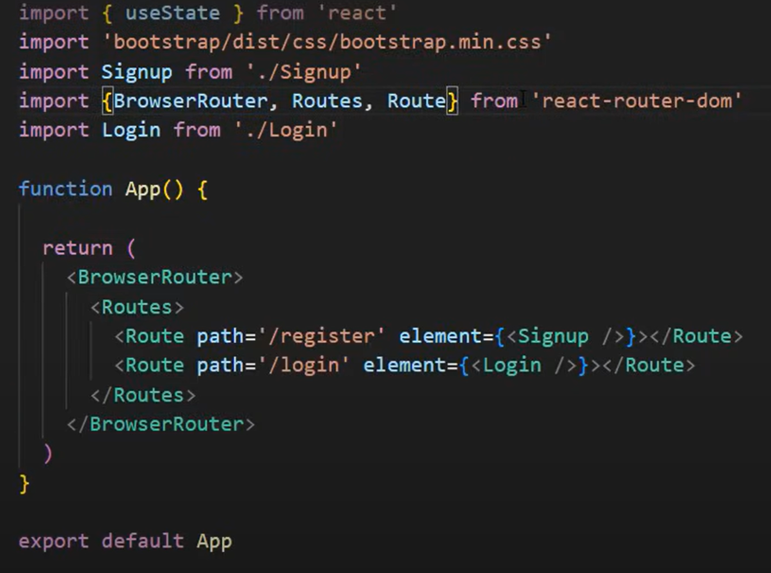

Link to Login.jsx in Signup.jsx form

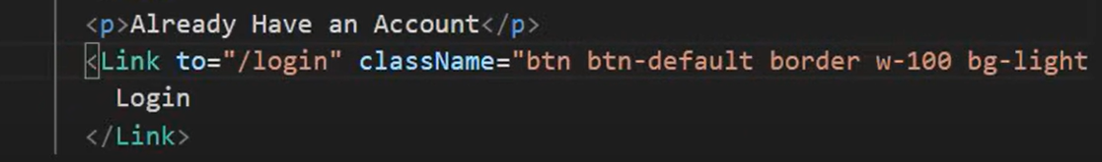

useState(), onChange, onSubmit:

* Create 3 states (name, email and password)
* Use it in text input
* For form <form onSubmit={handleSubmit}

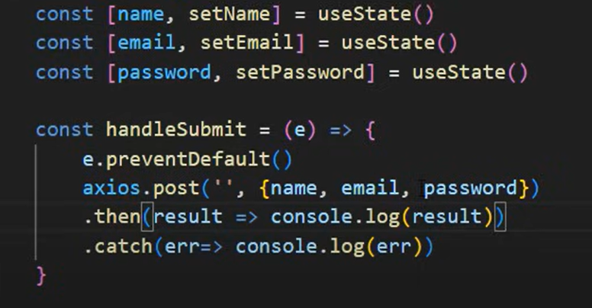

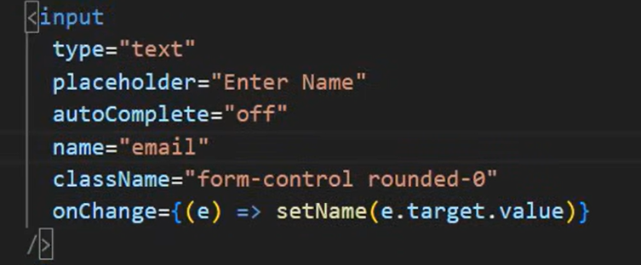

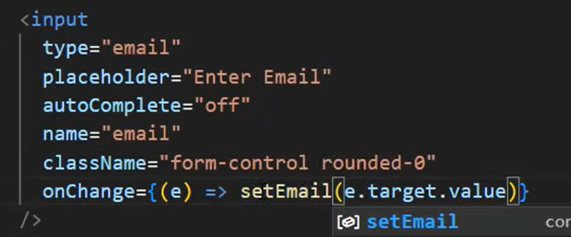

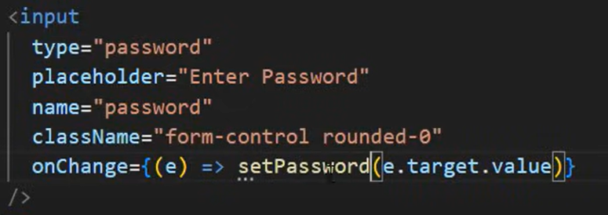

**Moving to Server side:**

**Database**

* Create database ‘employee’ and collection ‘register’ in compass
* Create a **Employee.js model** in same folder or in new folder

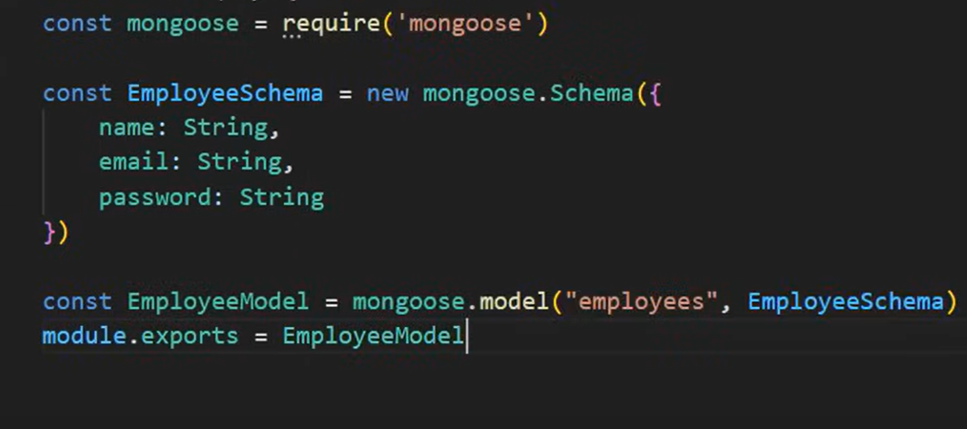

**Create index.js file in server side folder / node js:**

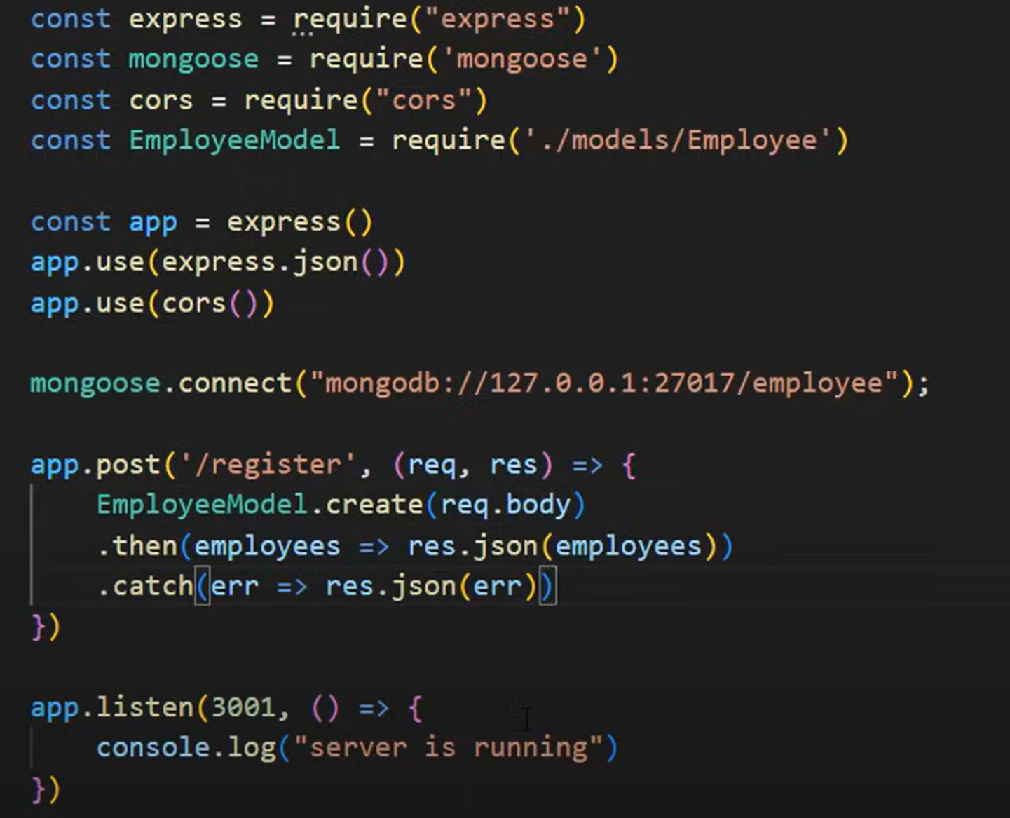

* Now it should take the data from form and insert into database
* After Registration, it should go to login page, for that add useNavigate() hook to previously created code
* Import {useNavigate} from ‘react-router-dom’ , add it to react document
* 
* Const navigate=useNavigate()
* 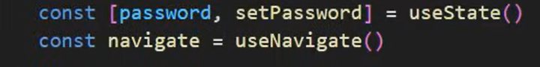
* Change some code in axios…
* 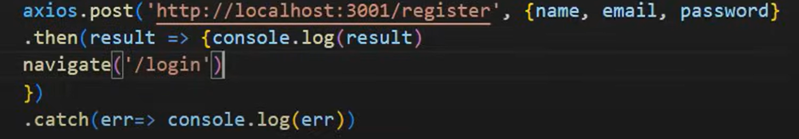

Below is total code:

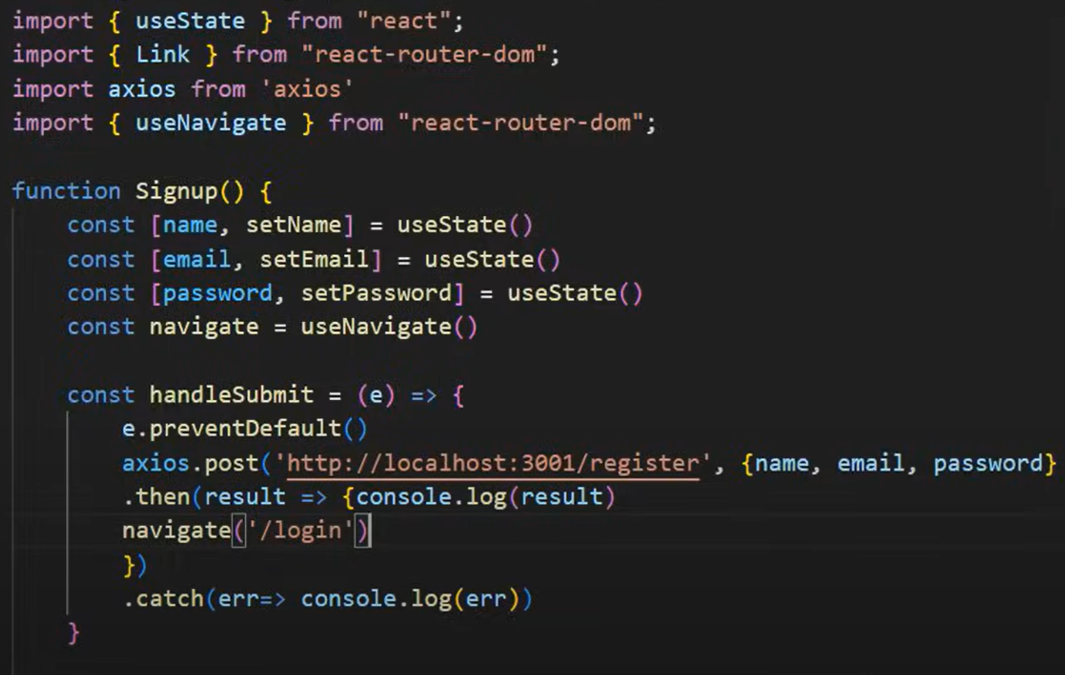

**Login Page:**

* For login validation we need email and password only.
* So copy entire form code of Signup, paste and do little changes to code

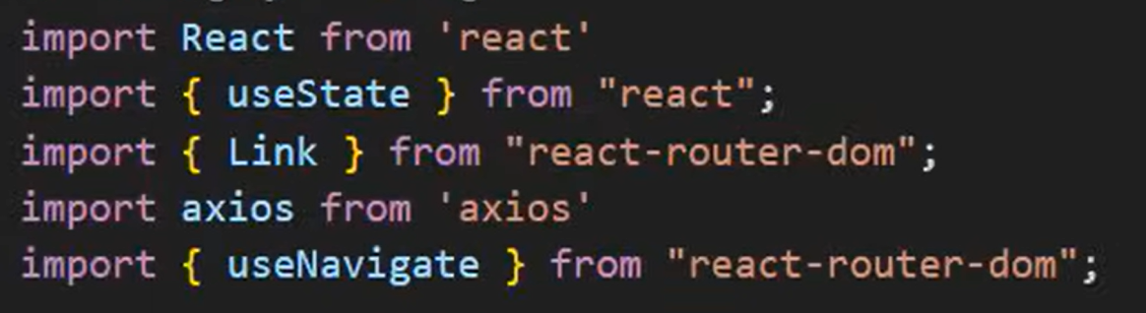

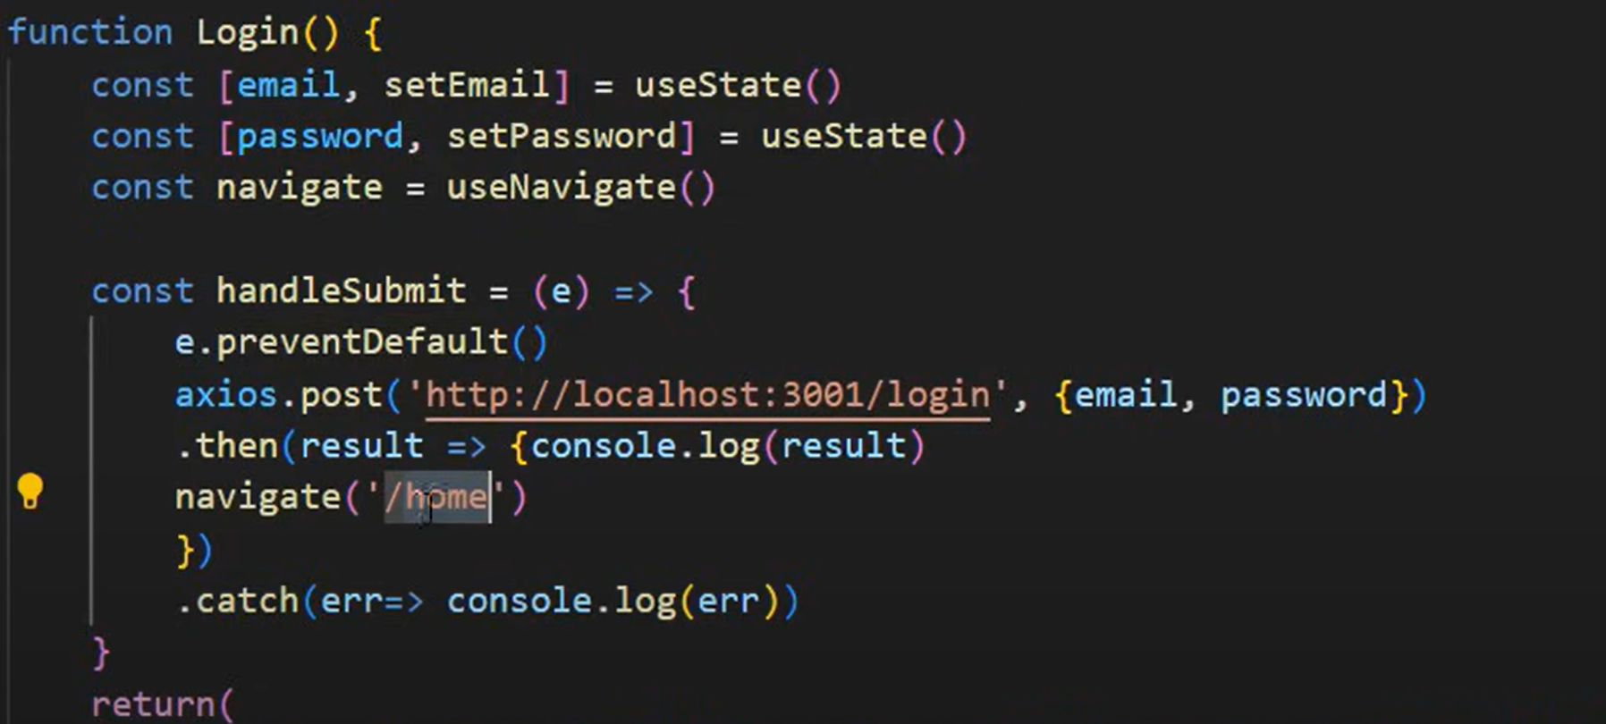

Creating Login route in server/node (index.js):

Validation to check whether user available or not

If available password validation

Index.js

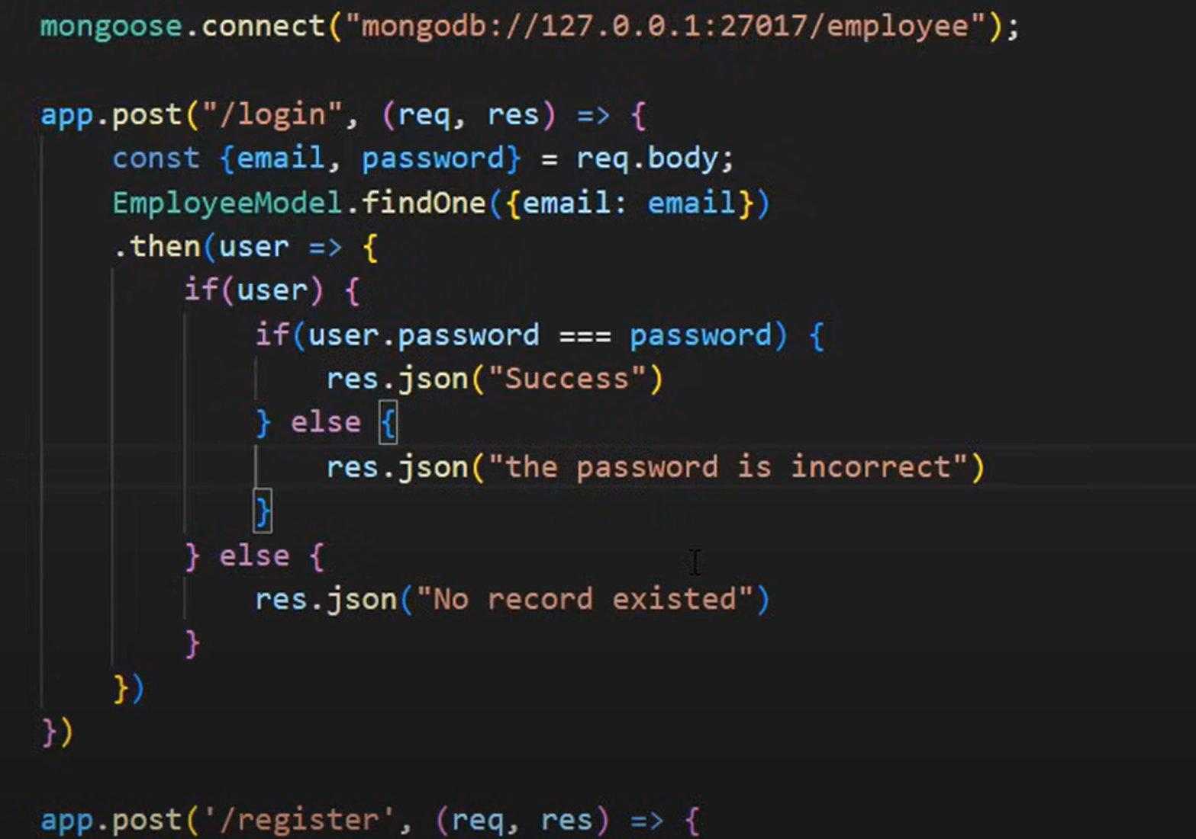

**React Login page:**

If email and password matching, then it should move to ‘/home’ route (we need to create)

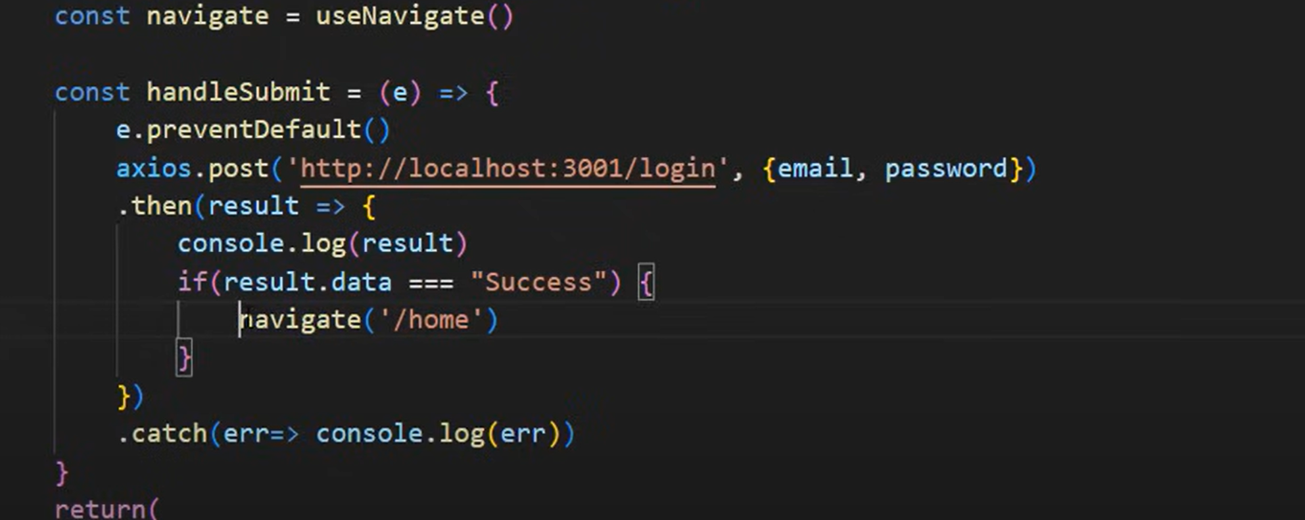

**Home.jsx in React:**

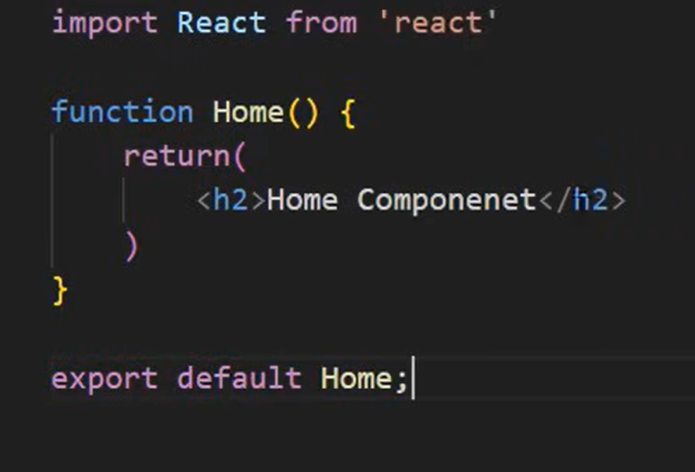

Create a route in react =>App.jsx

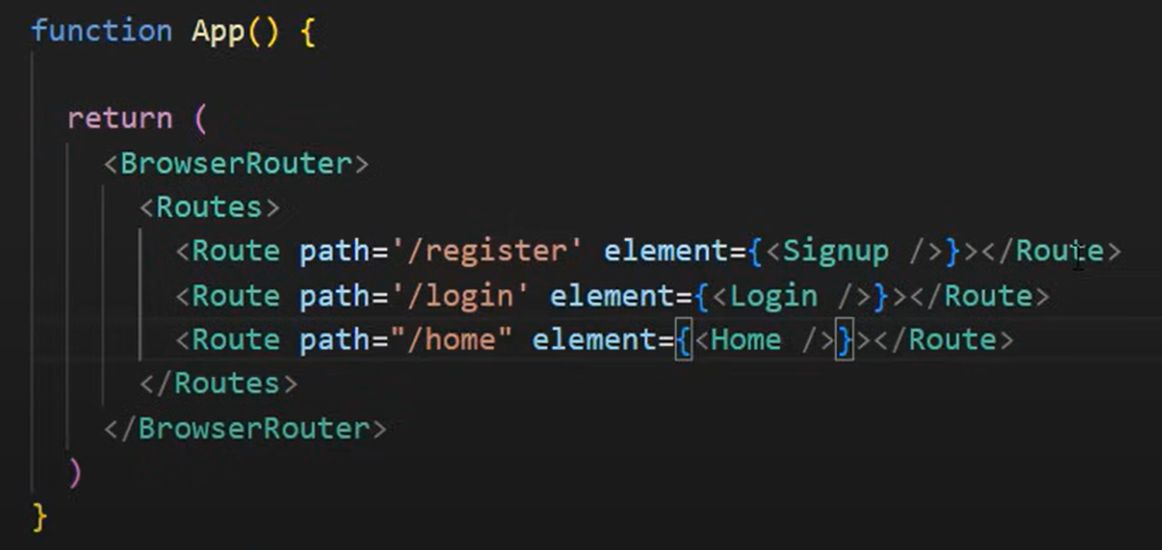

**JSON Web Token (JWT)**

**JSON Web Token (JWT)** is a compact, URL-safe means of securely transmitting information between parties as a JSON object. JWT is a simple text string that can be used by the client and server to authenticate and transfer the information easily.  A Token is encoded from a payload data using a secret key. That token is passed to the client. Whenever the client sends that token along with a request, the server validates it and sends back the response. Basically, JWT allows authentication without actually storing the user information on the system itself.

## Below is the data flow using JWT –

1. A client sends the username and password to the server.
2. The server validates the authentication. If the authentication is successful, the server creates a JWT token for the client and sends it to the client in response. If authentication is unsuccessful, the server will send an error to the client.
3. From the next request, the client for making any request supplies the JWT token in request headers like this.**Authorization: Bearer <jwt_token>**
4. The server upon receiving the JWT validates it and sends the successful response else error.

## Below is the data flow diagram for the JWT Flow.

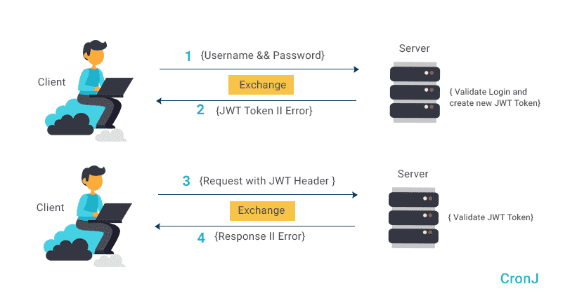

### The JWT Format –

Suppose a user tries to log in the application and on the successful authentication, the user will get a token in response. The token will look like this.

eyJ0eXAiOiJKV1QiLCJhbGciOiJIUzI1NiJ9.eyJzdWIiOiIxMjM0NTY3ODkwIiwibmFtZSI6IkpvaG4gRG9lIiwiYWRt aW4iOnRydWUsImp0aSI6IjY3NzM4Yjk2LWE2NzYtNDBlYy1hNzc3LTNhZmRjZThkYWUyNSIsImlhdCI6MTU4Mj Y5MzAyNywiZXhwIjoxNTgyNjk2NjI3fQ.NiUXgZZruVFsf8uZAveMO7NieYqbJqzTGcByHZMb5zU

A JWT Token mainly consists of three parts separated by (.) dots.

1. Header
2. Payload
3. Signature

1. **Header** – The header consists of two parts, the type of token, that is JWT and the hashing algorithm that is being used such as HMAC,  SHA256 or RSA.

For Example –

{

 "alg”: "HS256”,

 "typ": "JWT"

}

From the above JWT example, the header part is.

      eyJ0eXAiOiJKV1QiLCJhbGciOiJIUzI1NiJ9

1. **Payload** – The second part of the Token is the payload. The payload contains application-specific information usually user information along with other options that may contain expiry and validity of the token.

{

 "username”: "user1@gmail.com”,

 "password": "user@12345"

}

From the above JWTM, the payload is –

eyJzdWIiOiIxMjM0NTY3ODkwIiwibmFtZSI6IkpvaG4gRG9lIiwiYWRtaW4iOnRydWUsImp0aSI6IjY3NzM4Yjk2L WE2NzYtNDBlYy1hNzc3LTNhZmRjZThkYWUyNSIsImlhdCI6MTU4MjY5MzAyNywiZXhwIjoxNTgyNjk2NjI3fQ

3 **Signature** –  The third part of the Token is signature. Signature is generated by combining the first two parts of the Token with a secret key. The signature is used to verify that the sender of the JWT and to ensure that the message was not changed along the way.

Ex:

const express=require('express')

const jwt=require('jsonwebtoken')

const app=express()

app.get('/api',function(req,res){

res.json({

text:'my api'

})

})

app.post('/login',(req,res)=>{

const user={id:3}

const token=jwt.sign({user},'my_secret_key')

res.json({

token:token

})

})

app.get('/api/protected',function(req,res){

res.json({

text:'this is protected'

})

})

app.listen(3000,()=>console.log("server started"))

=================================================

2

==>localhost/api/login =>take token

=>2nd tab

localhost/api/protected

=>headers

key

Authorization

value bear token code

=>it should display =>{"text":"this is protected"} if checkbox on beside autorization other wise unauthorised...

--------------------------------------------------------

const express=require('express')

const jwt=require('jsonwebtoken')

const app=express()

app.get('/api',function(req,res){

res.json({

text:'my api'

})

})

app.post('/login',(req,res)=>{

const user={id:3}

const token=jwt.sign({user},'my_secret_key')

res.json({

token:token

})

})

app.get('/api/protected', ensuretoken, function(req,res){

res.json({

text:'this is protected'

})

})

function ensuretoken(req,res,next){

const bearerHeader=req.headers['authorization']

if(typeof bearerHeader !== 'undefined'){

const bearer=bearerHeader.split(" ")

const bearerToken=bearer[1]

req.token=bearerToken

next()

}else{

res.sendStatus(401)

}

}

app.listen(3000,()=>console.log("server started"))

-----------------------------

3

const express=require('express')

const jwt=require('jsonwebtoken')

const app=express()

app.get('/api',function(req,res){

res.json({

text:'my api'

})

})

app.post('/login',(req,res)=>{

const user={id:3}

const token=jwt.sign({user},'my_secret_key')

res.json({

token:token

})

})

app.get('/api/protected', ensuretoken, function(req,res){

jwt.verify(req.token, 'my_secret_key',function(err,data){

if(err){

res.sendStatus(403)

}else{

res.json({

text:'this is protected',

data:data

})

}

})

})

function ensuretoken(req,res,next){

const bearerHeader=req.headers['authorization']

if(typeof bearerHeader !== 'undefined'){

const bearer=bearerHeader.split(" ")

const bearerToken=bearer[1]

req.token=bearerToken

next()

}else{

res.sendStatus(401)

}

}

app.listen(3000,()=>console.log("server started"))